Stage 1: Create the Employees Table

Question:

**Create a table named employees.
*Add the following 8 columns:
●emp_id
●emp_name
●email
●department
●job_role
●salary
●age
●city
▪︎Apply appropriate constraints:
●PRIMARY KEY
●NOT NULL
●UNIQUE
●CHECK
●DEFAULT

SQL Query:
CREATE TABLE employees (
emp_id INT PRIMARY KEY,
emp_name VARCHAR(100) NOT NULL,
email VARCHAR(100) UNIQUE NOT NULL,
department VARCHAR(50) NOT NULL,
job_role VARCHAR(50) NOT NULL,
salary DECIMAL(10,2) CHECK (salary > 0),
age INT CHECK (age >= 18),
city VARCHAR(50) DEFAULT 'Hyderabad'
);
Output:
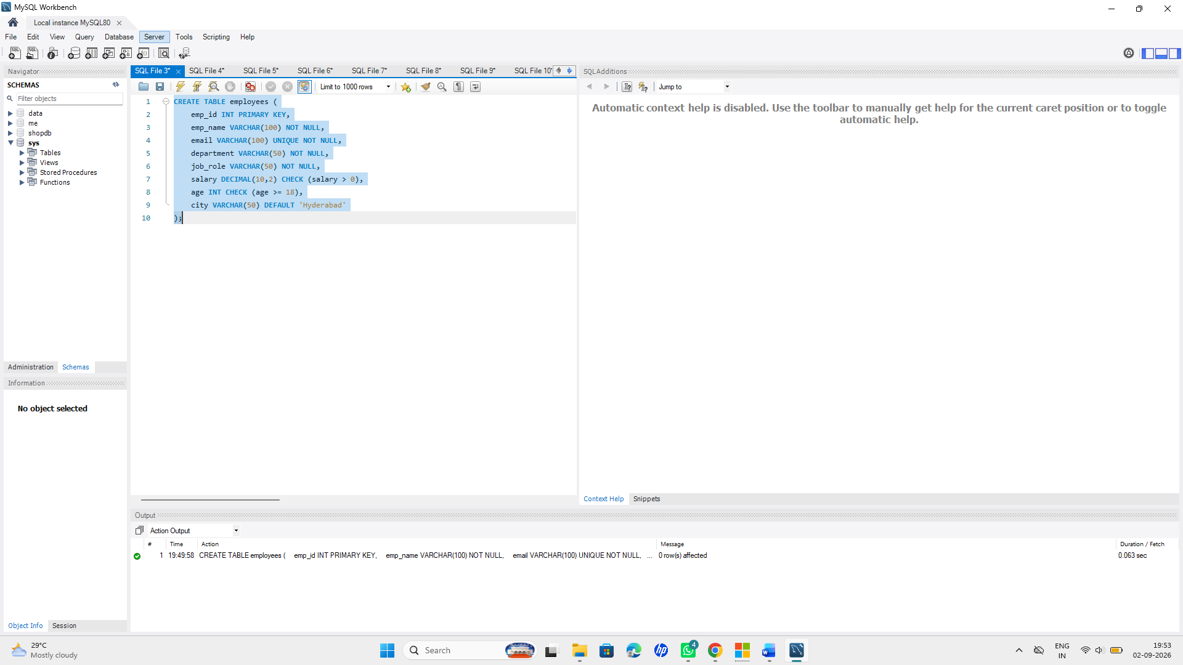
Stage 2: Insert Employee Data

Question:

●Insert 20 realistic employee records.

☆Include:
●At least 4 different departments.
●At least 4 different cities.
●Different job roles.
●Different salary values.
●Different age values.
●Some repeated salaries.
●Some repeated cities.
●At least one NULL city.

☆SQL Query:

INSERT INTO employees
(emp_id, emp_name, email, department, job_role, salary, age, city)
VALUES
(1, 'Rahul Sharma', 'rahul@gmail.com', 'IT', 'Software Developer', 60000, 24, 'Hyderabad'),
(2, 'Priya Reddy', 'priya@gmail.com', 'HR', 'HR Executive', 45000, 26, 'Vijayawada'),
(3, 'Arjun Kumar', 'arjun@gmail.com', 'Finance', 'Accountant', 50000, 28, 'Chennai'),
(4, 'Sneha Rao', 'sneha@gmail.com', 'Marketing', 'Marketing Executive', 40000, 23, 'Bangalore'),
(5, 'Kiran Reddy', 'kiran@gmail.com', 'IT', 'Web Developer', 55000, 25, 'Hyderabad'),
(6, 'Anjali Singh', 'anjali@gmail.com', 'Finance', 'Financial Analyst', 65000, 29, 'Mumbai'),
(7, 'Vamsi Krishna', 'vamsi@gmail.com', 'IT', 'Software Engineer', 60000, 27, 'Vijayawada'),
(8, 'Divya Patel', 'divya@gmail.com', 'HR', 'Recruiter', 45000, 24, 'Bangalore'),
(9, 'Rohit Verma', 'rohit@gmail.com', 'Marketing', 'Sales Executive', 50000, 30, 'Chennai'),
(10, 'Pooja Nair', 'pooja@gmail.com', 'Finance', 'Finance Manager', 75000, 32, 'Mumbai'),
(11, 'Suresh Babu', 'suresh@gmail.com', 'IT', 'Database Administrator', 70000, 31, 'Hyderabad'),
(12, 'Meena Devi', 'meena@gmail.com', 'HR', 'HR Manager', 65000, 35, 'Vijayawada'),
(13, 'Ajay Kumar', 'ajay@gmail.com', 'Marketing', 'Digital Marketer', 55000, 26, 'Bangalore'),
(14, 'Lakshmi Priya', 'lakshmi@gmail.com', 'Finance', 'Accountant', 50000, 27, 'Chennai'),
(15, 'Naveen Reddy', 'naveen@gmail.com', 'IT', 'Data Analyst', 65000, 29, 'Hyderabad'),
(16, 'Swathi Rao', 'swathi@gmail.com', 'HR', 'HR Executive', 45000, 25, 'Bangalore'),
(17, 'Manoj Kumar', 'manoj@gmail.com', 'Marketing', 'Marketing Manager', 70000, 34, 'Mumbai'),
(18, 'Keerthi Sharma', 'keerthi@gmail.com', 'Finance', 'Financial Analyst', 60000, 28, NULL),
(19, 'Ravi Teja', 'ravi@gmail.com', 'IT', 'Software Engineer', 60000, 26, 'Vijayawada'),
(20, 'Harika Reddy', 'harika@gmail.com', 'Marketing', 'Content Writer', 40000, 22, 'Chennai');
**Output:
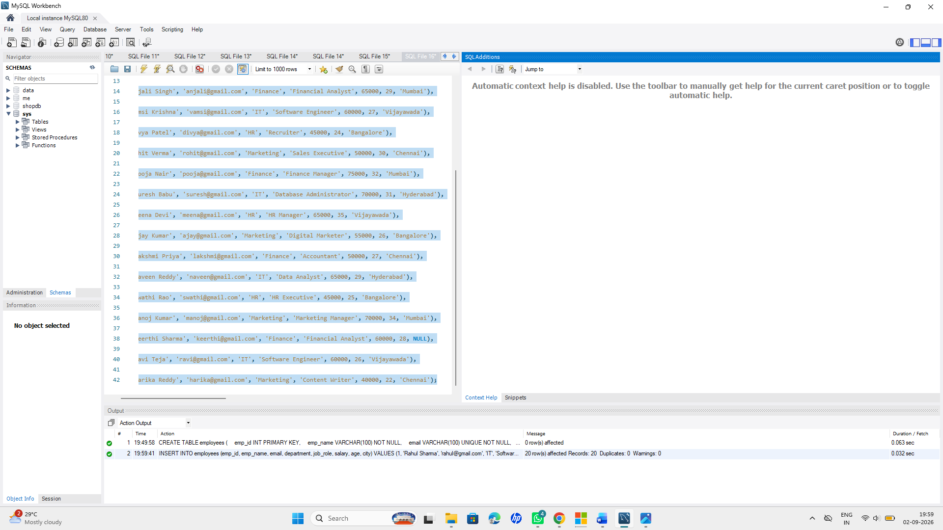

Stage 3: SELECT Queries

Question:

●Display all employee records.
●employee name.
●department.
●salary.
● city.
●Retrieve employees based on specific conditions using SELECT.

☆SQL Query:

-- 1.
SELECT * FROM employees;
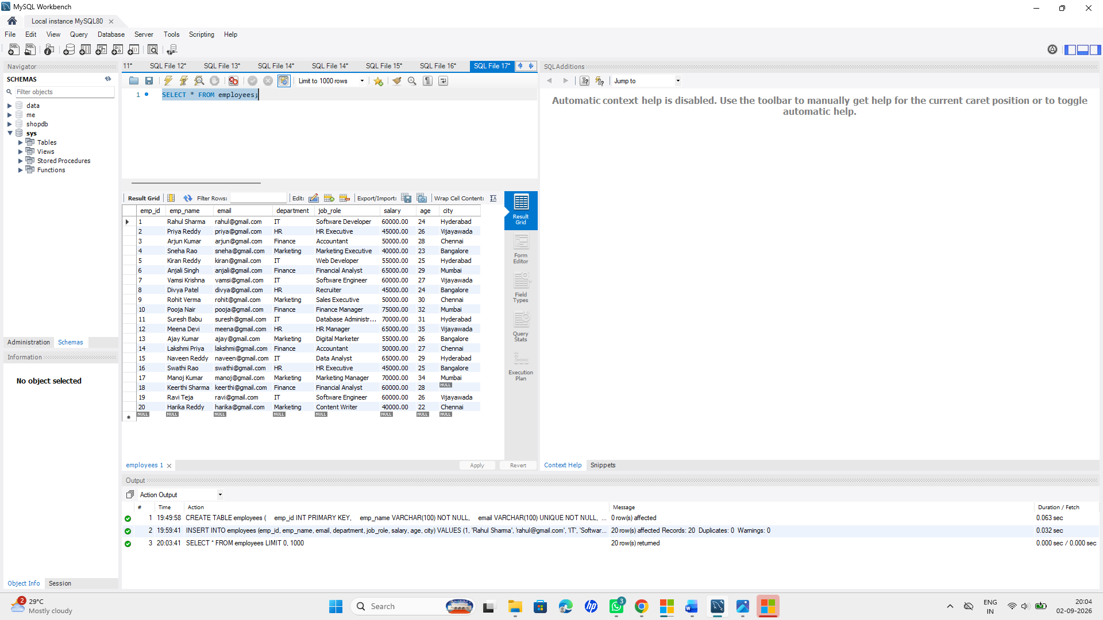

-- 2.
SELECT emp_name FROM employees;
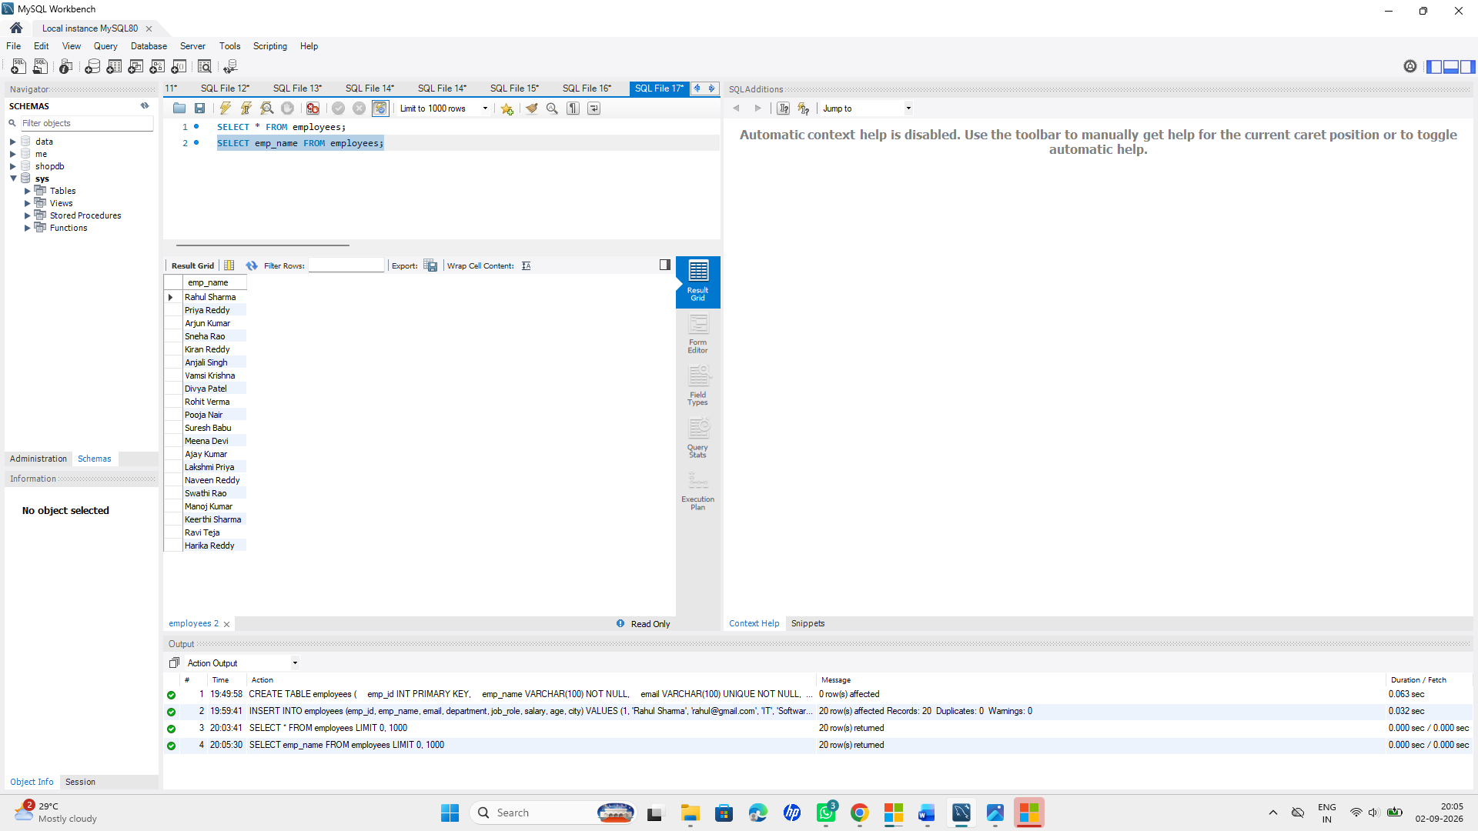

-- 3.
SELECT department FROM employees;
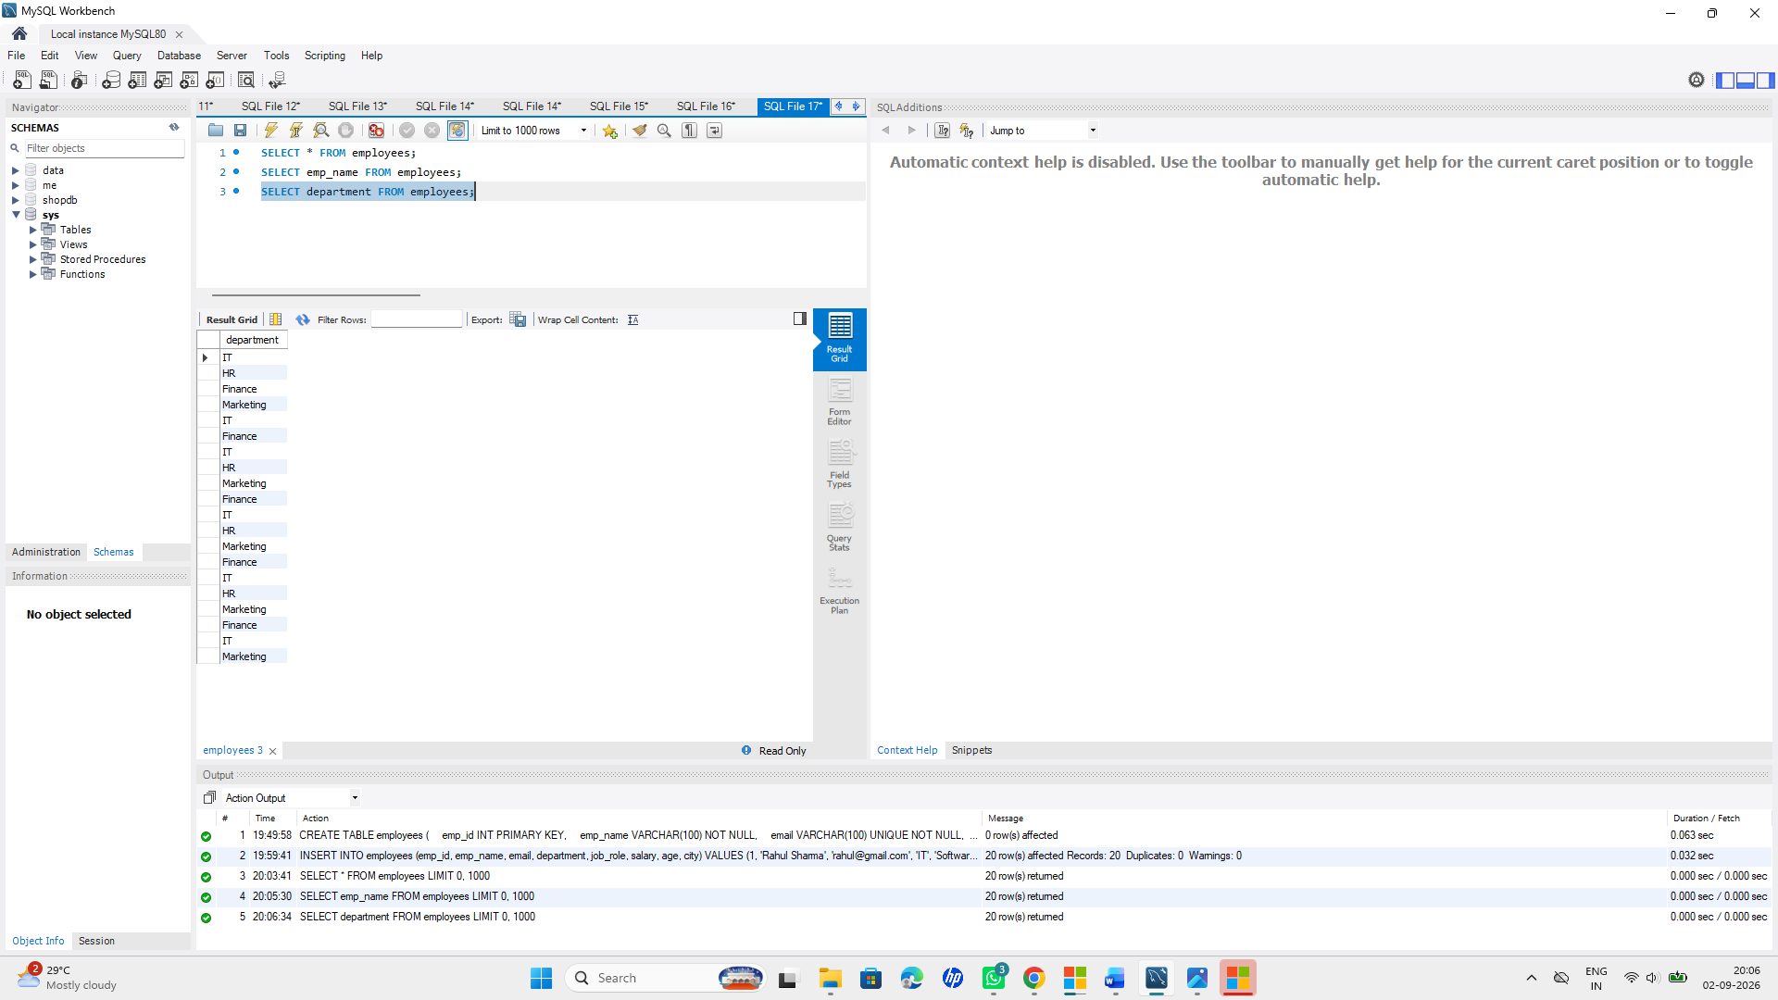

-- 4.
SELECT salary FROM employees;
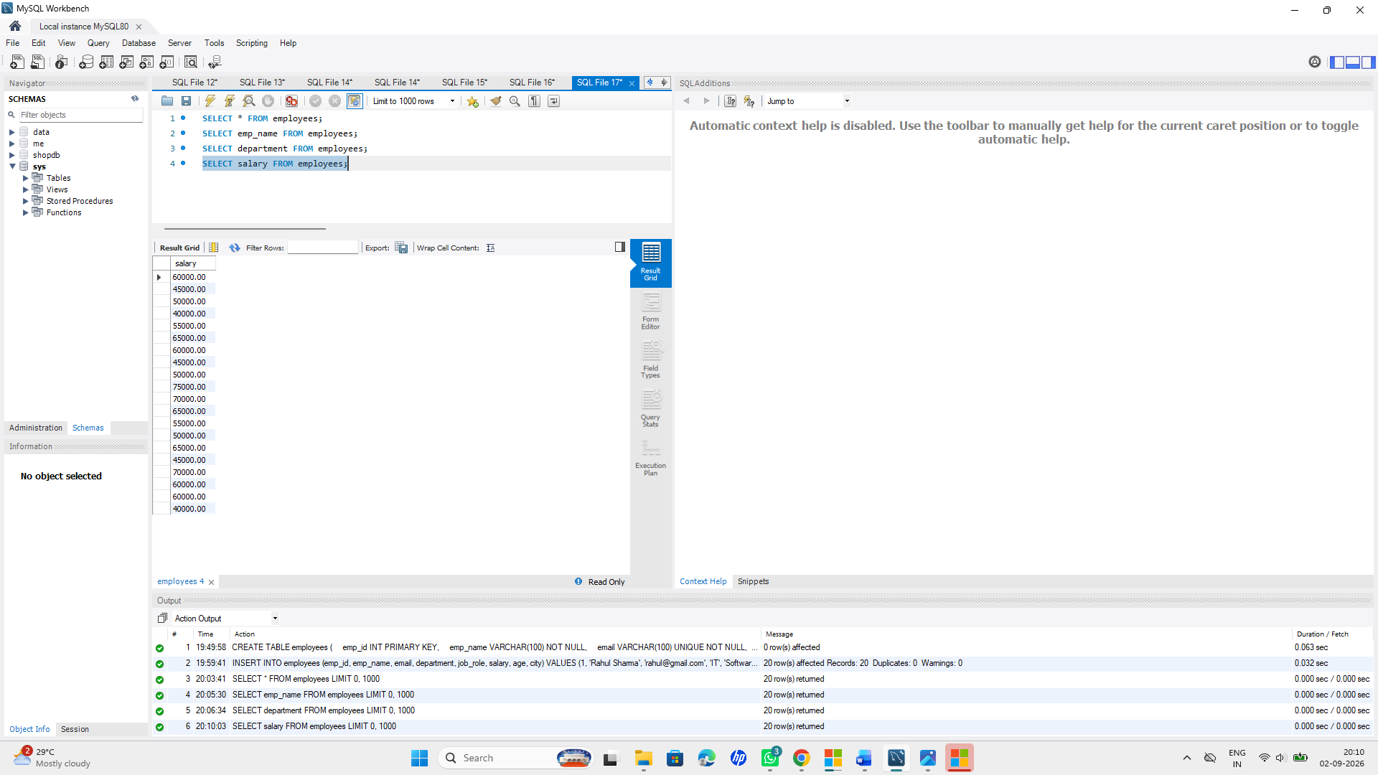
-- 5.
SELECT city FROM employees;
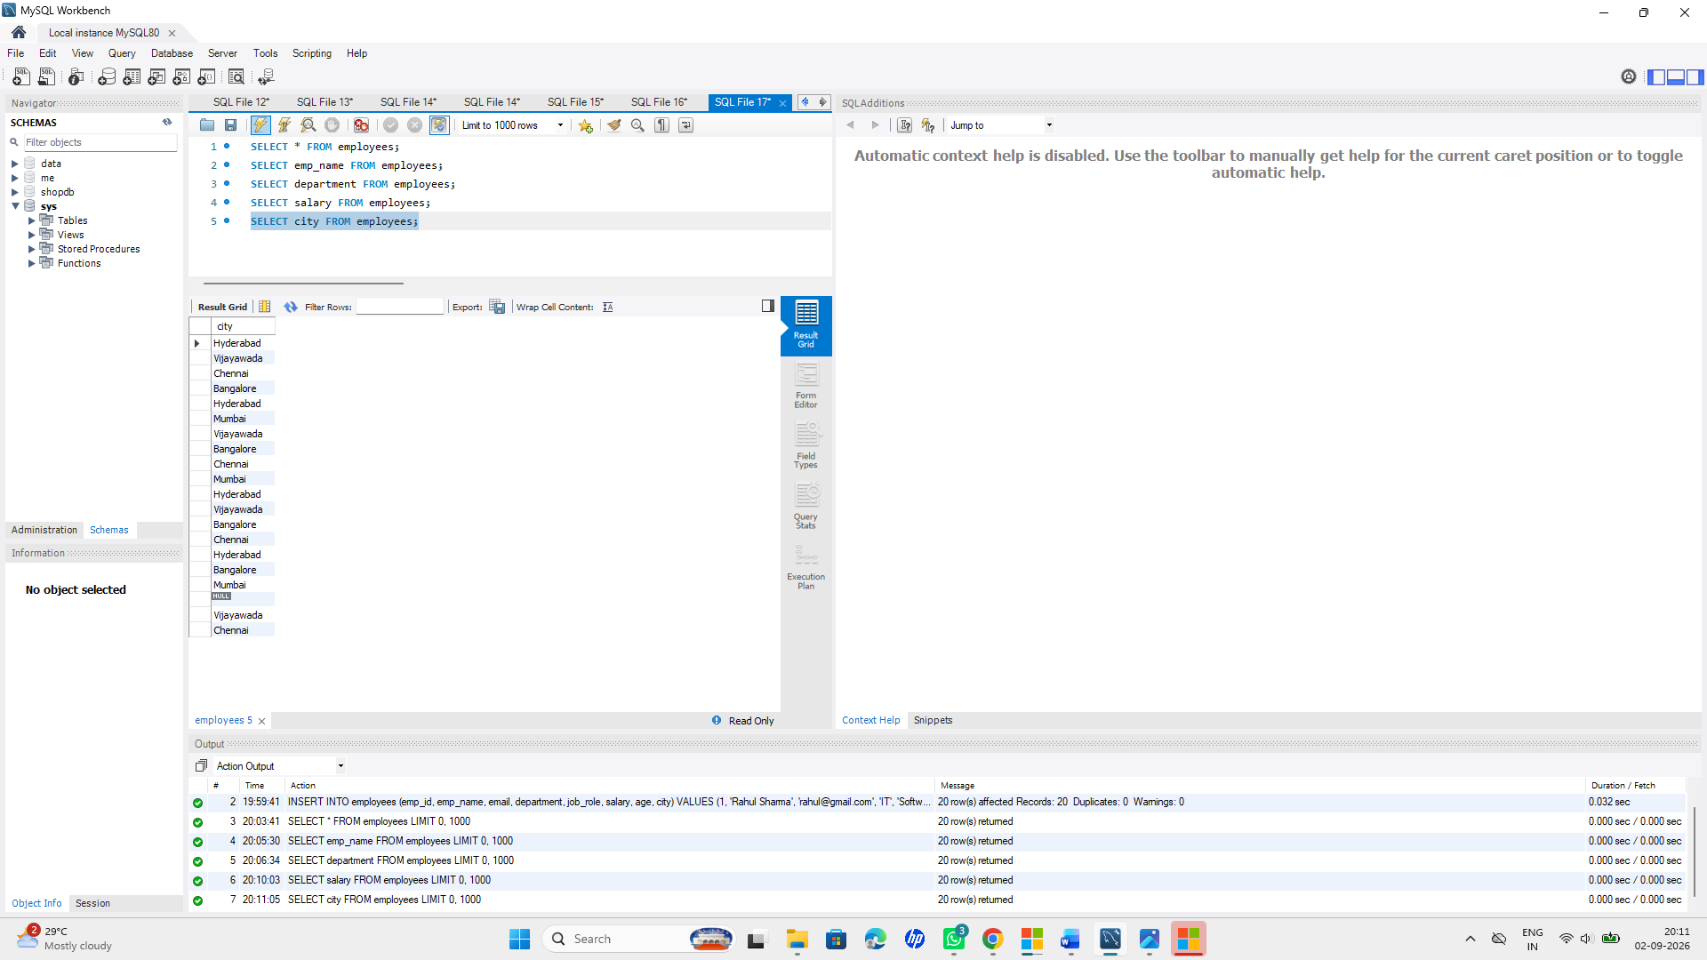

-- 6.
SELECT * FROM employees
WHERE salary > 50000;
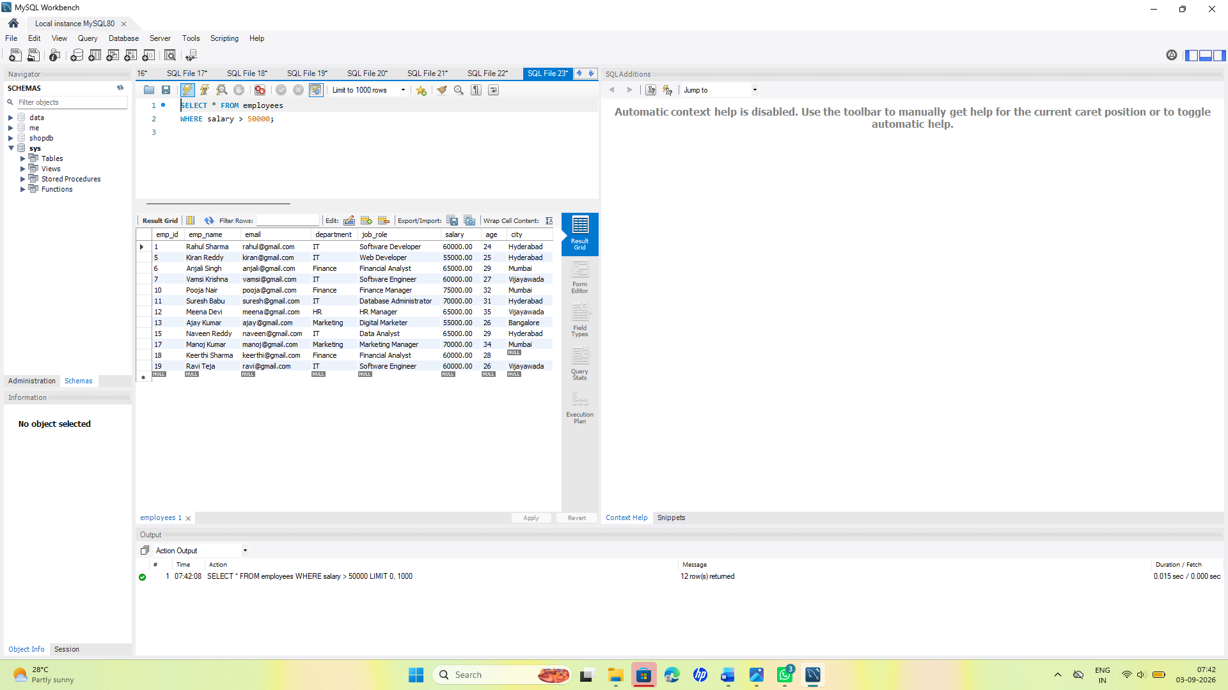

Stage 4: WHERE and Comparison Operators
**Question:
*Examples of conditions to practice:
*Find employees with salary equal to a specific amount using =.
*Find employees earning more than a specific salary using >.
*Find employees below a specific age using <.
*Find employees earning greater than or equal to a specific salary using >=.
*Find employees whose age is less than or equal to a specific age using <=.
*Find employees whose department is not a particular department using <>.
*Find employees whose department is not a particular department using !=.
SQL Query:
-- 1. =
SELECT * FROM employees
WHERE salary = 60000;
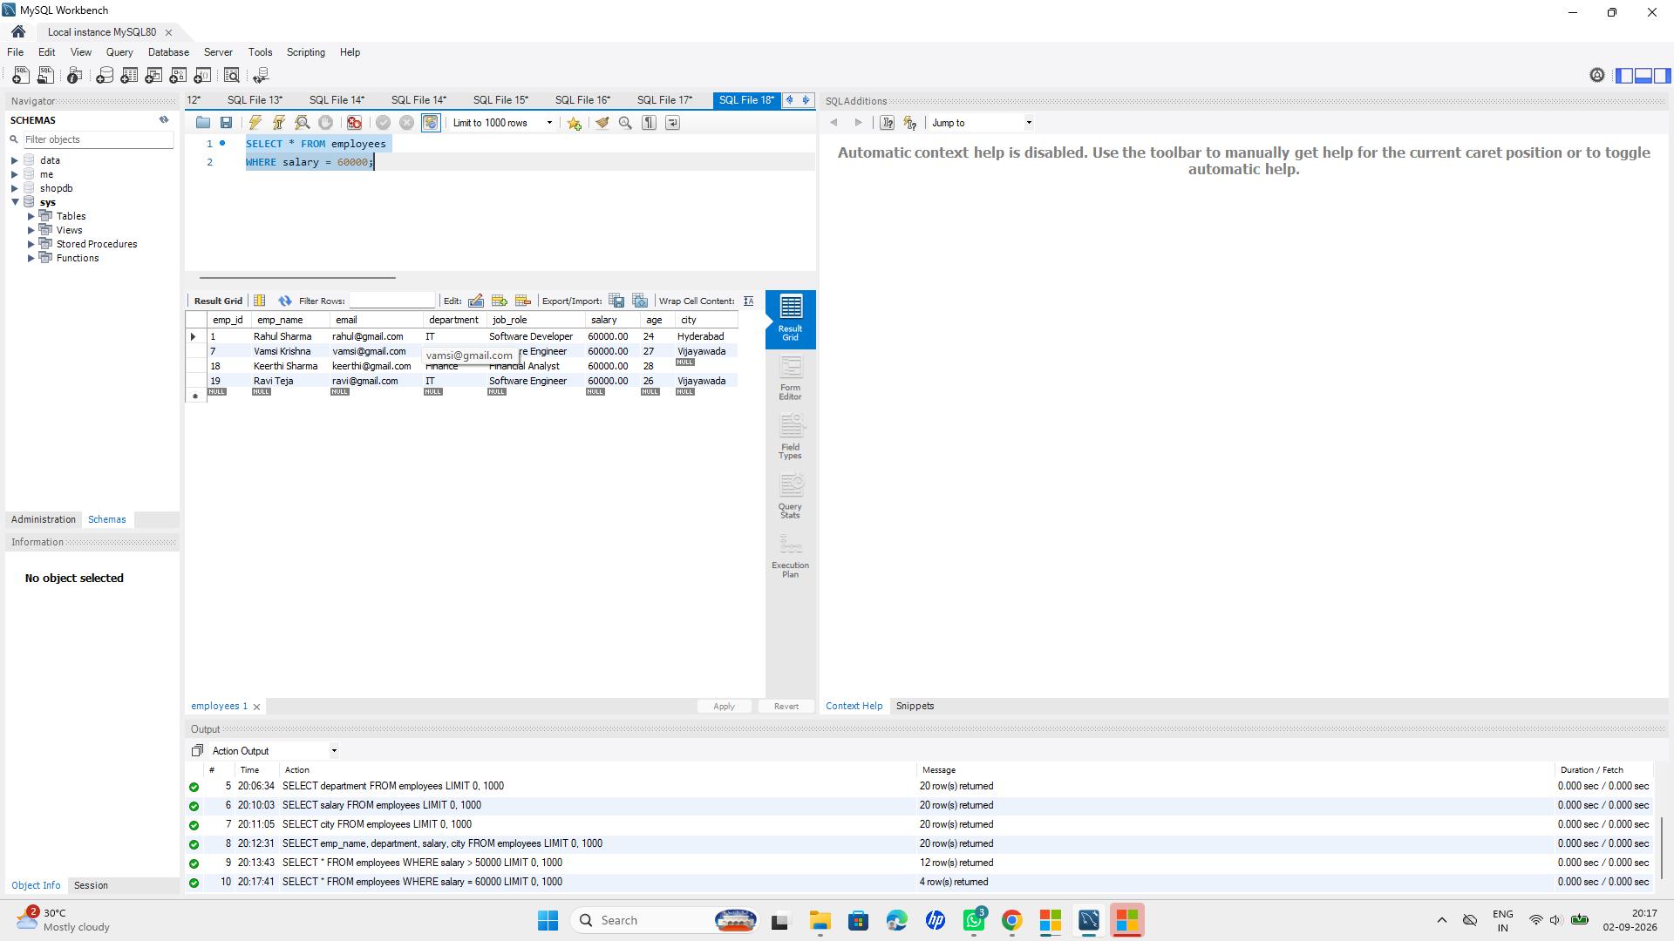

-- 2. >
SELECT * FROM employees
WHERE salary > 60000;
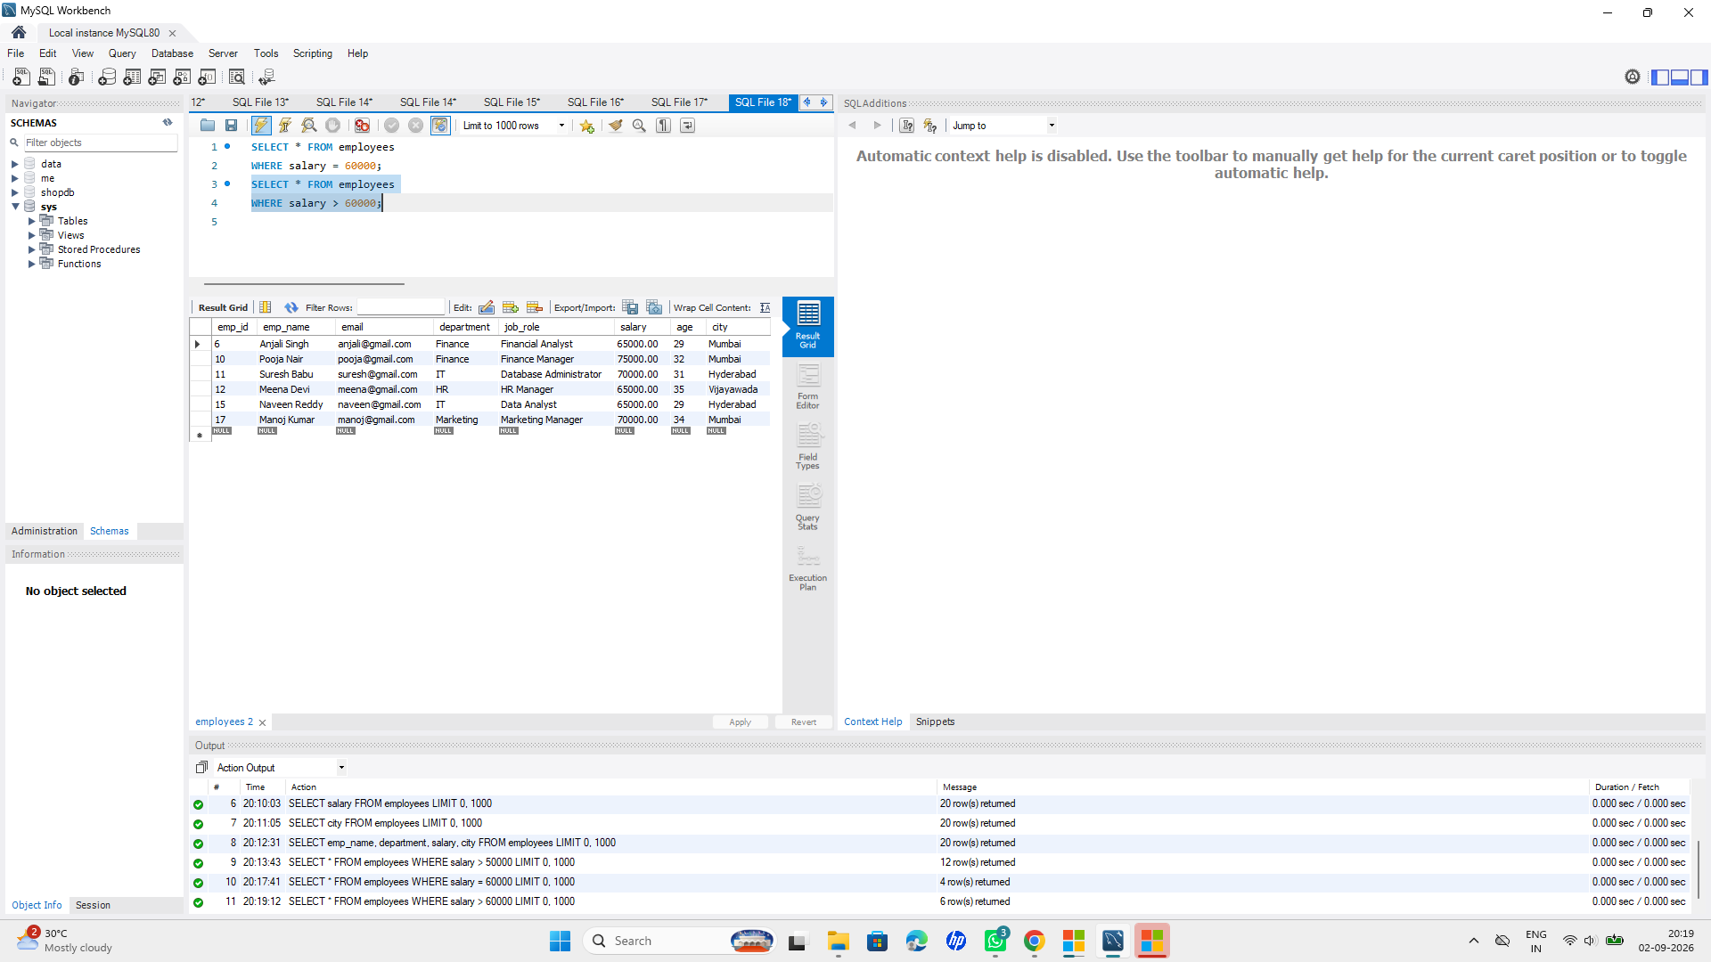

-- 3. <
SELECT * FROM employees
WHERE age < 25;
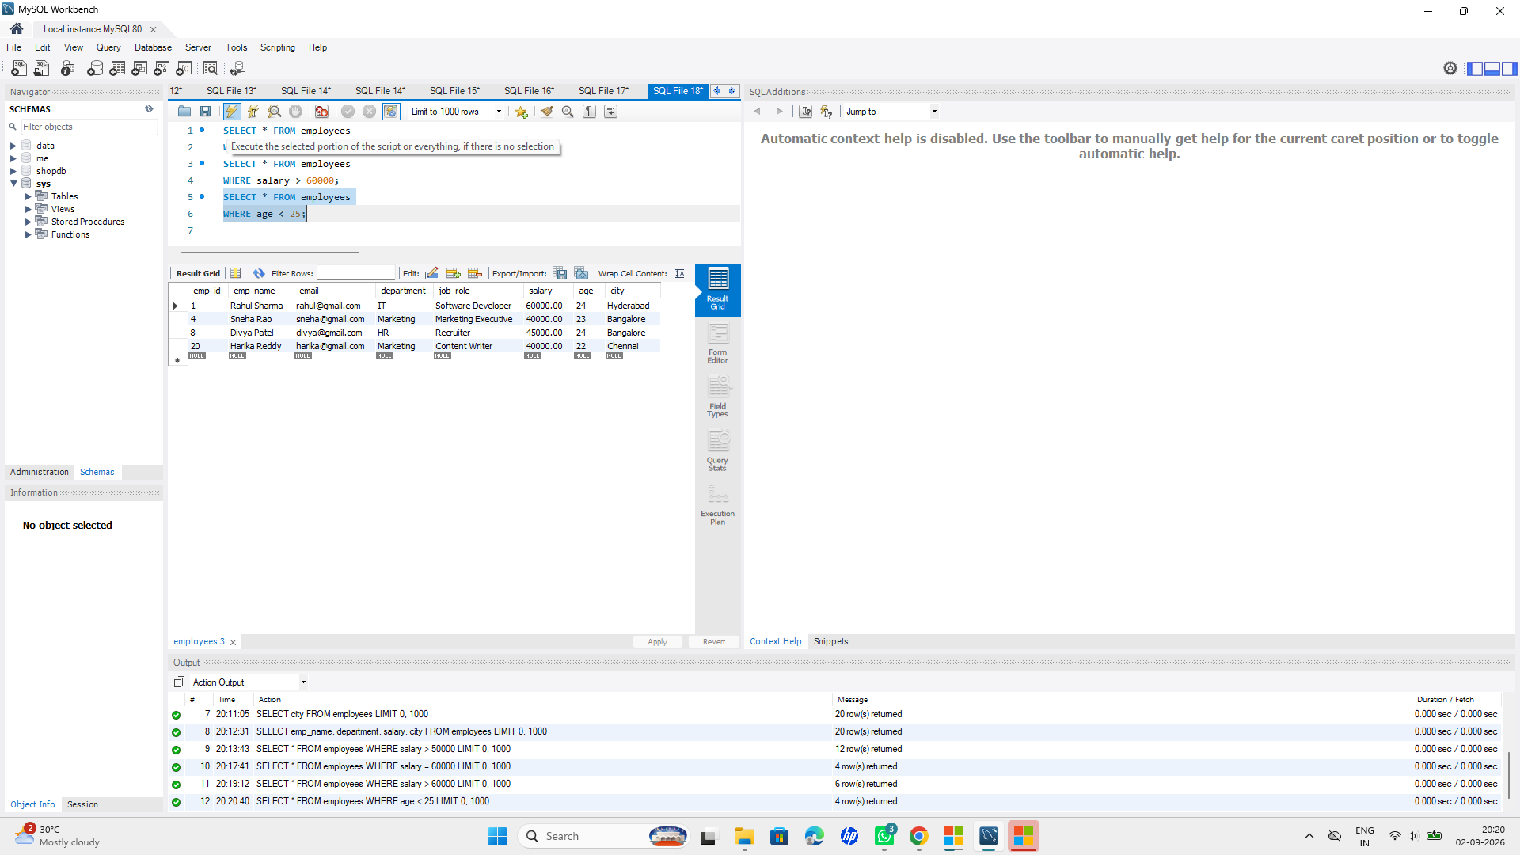

-- 4. >=
SELECT * FROM employees
WHERE salary >= 65000;
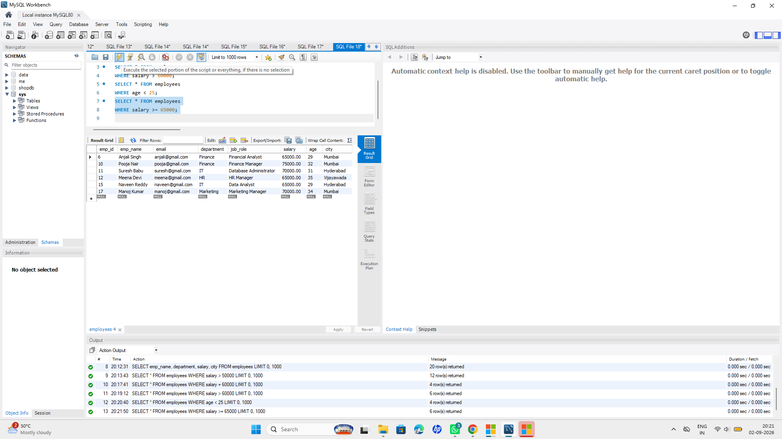

-- 5. <=
SELECT * FROM employees
WHERE age <= 25;
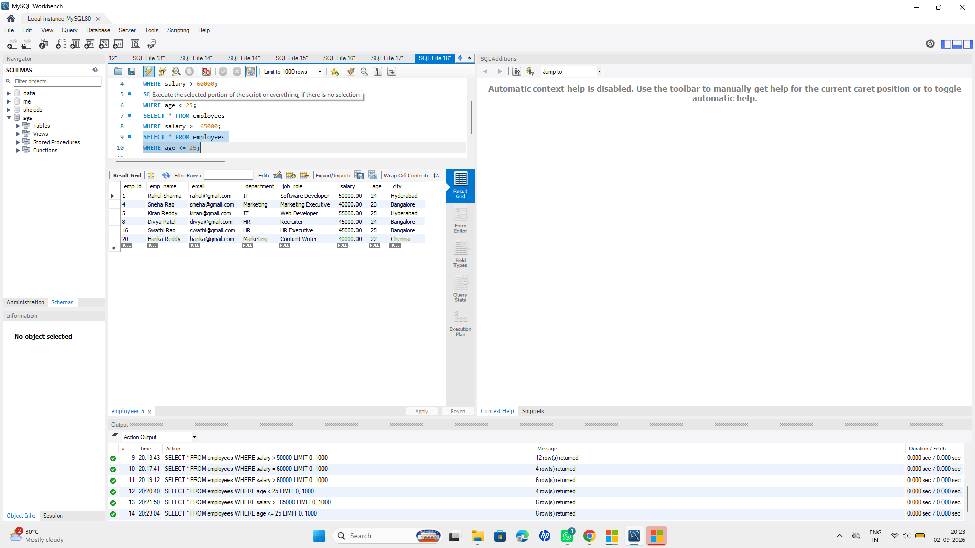

-- 6. <>
SELECT * FROM employees
WHERE department <> 'IT';
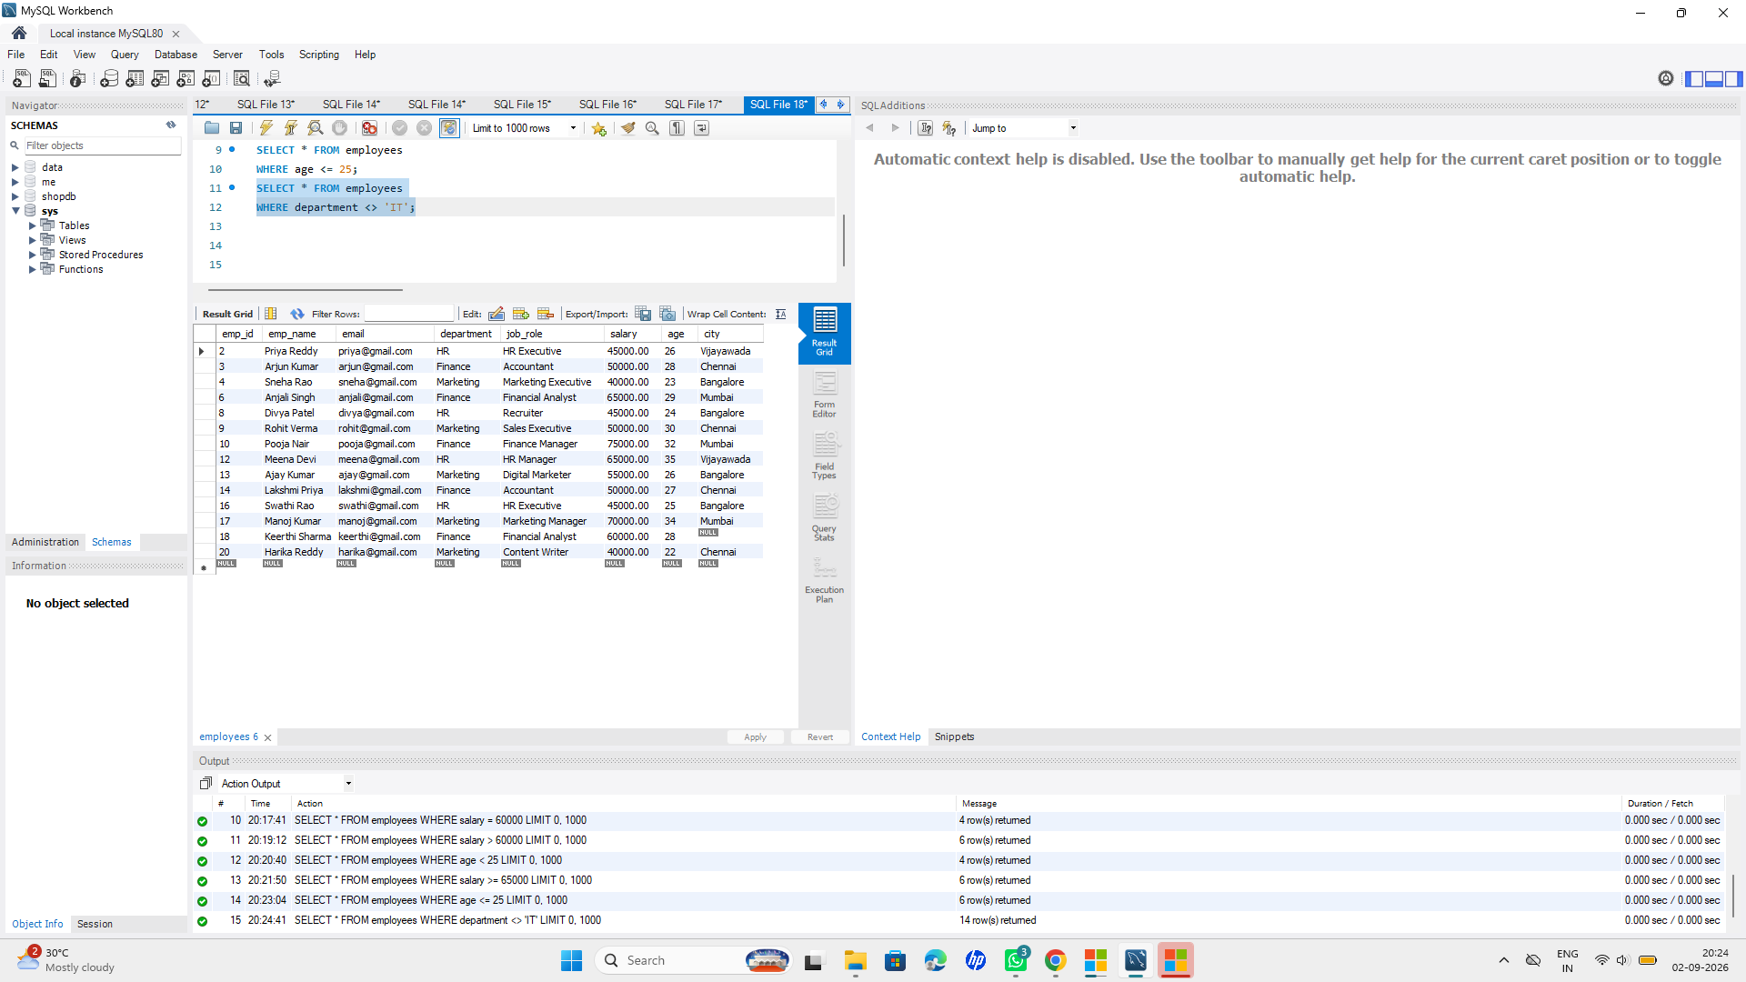

-- 7. !=
SELECT * FROM employees
WHERE department != 'HR';
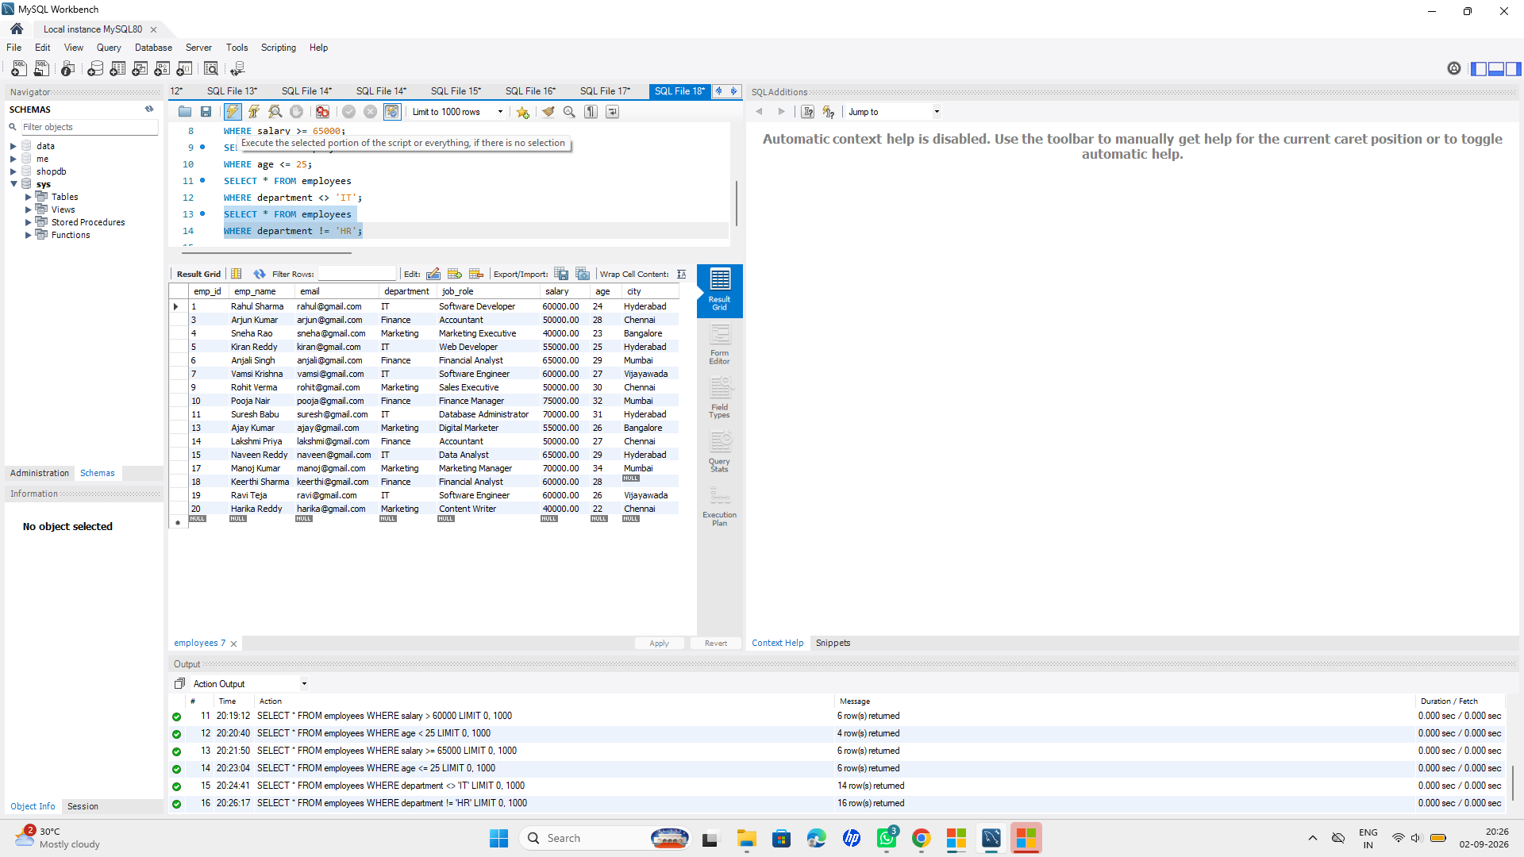

📌Stage 5: Logical Operators

Question:

Practice the following logical operators:

●AND
●OR
●NOT

Tasks:

●Find employees from a specific department AND earning above a given salary.
●Find employees from one department OR another department.
●Find employees who are NOT from a particular department.

☆SQL Query:
-- 1.
SELECT * FROM employees
WHERE department = 'IT' AND salary > 50000;
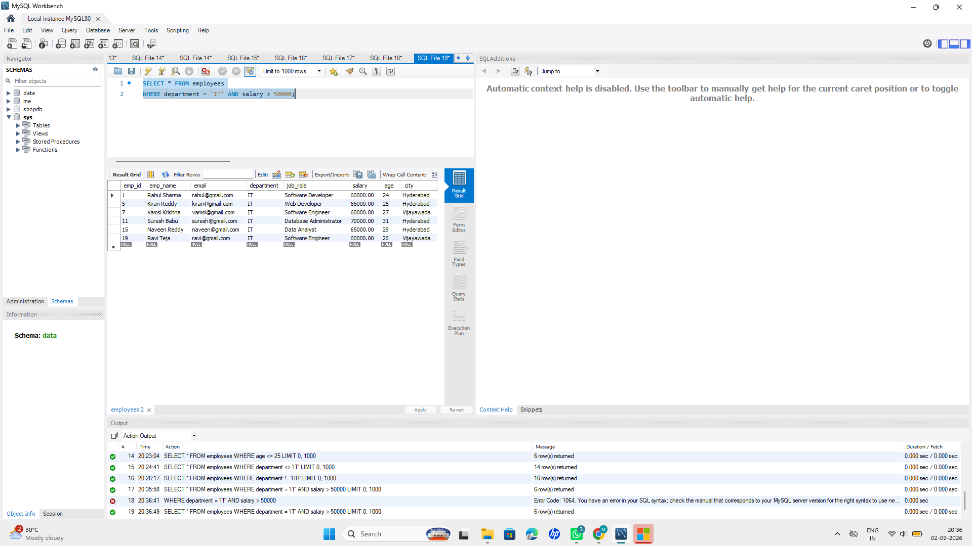

-- 2.
SELECT * FROM employees
WHERE department = 'IT' OR department = 'HR';
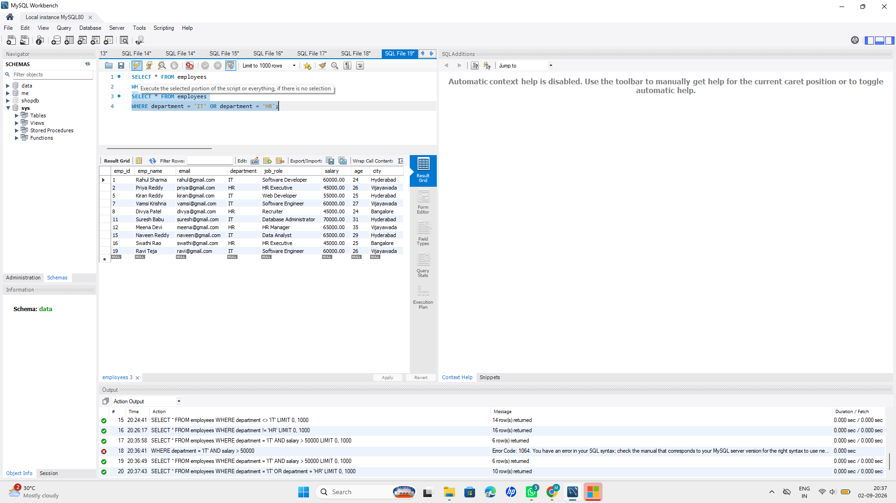

-- 3.
SELECT * FROM employees
WHERE NOT department = 'IT';
OUTPUT:
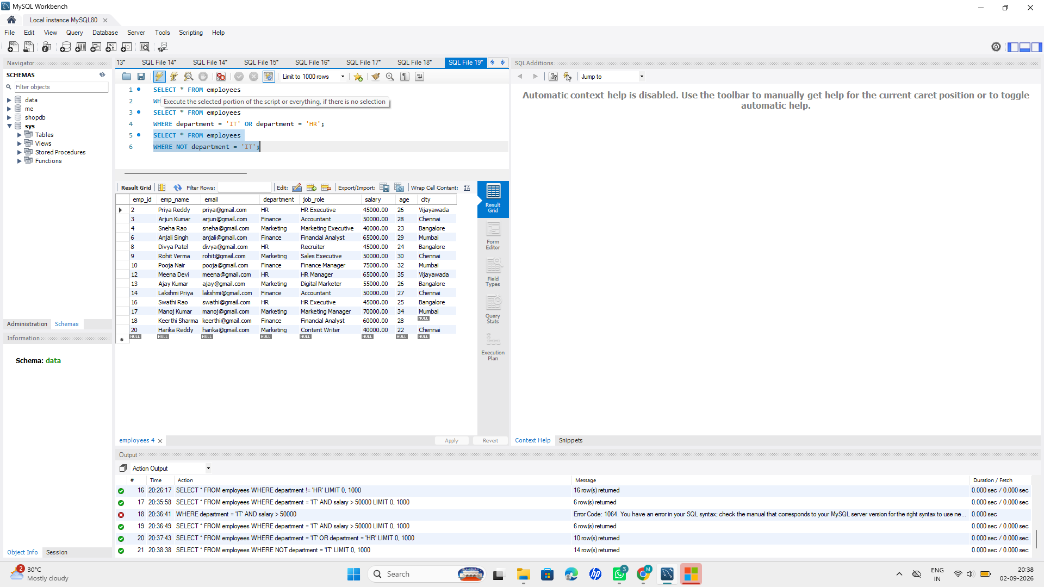

Stage 6 — Special Operators

Question:

●BETWEEN – Find employees whose salary or age falls within a range.
●IN – Find employees belonging to selected departments or cities.
●NOT IN – Exclude selected departments or cities.
●LIKE – Search employee names using patterns.
●IS NULL – Find employees whose city is NULL.
●IS NOT NULL – Find employees whose city is available.

☆Query:

1. SELECT * FROM employees
WHERE salary BETWEEN 30000 AND 60000;
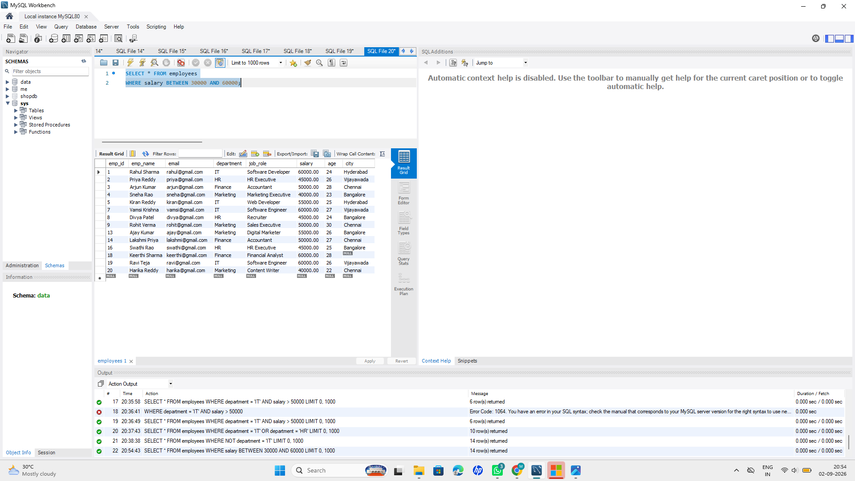

2. SELECT * FROM employees
WHERE department IN ('IT', 'HR', 'Sales');
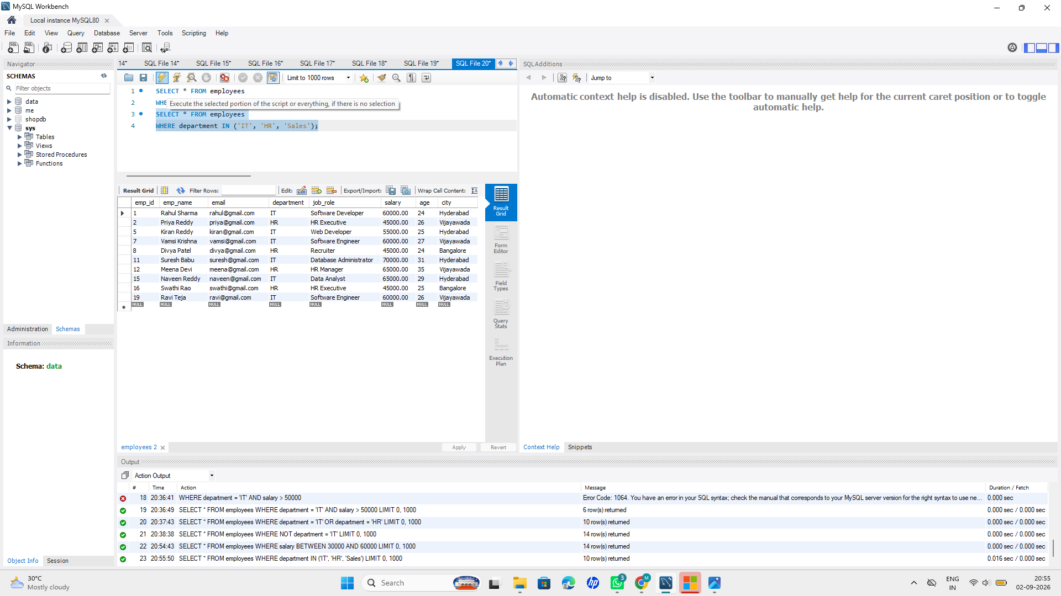

3. SELECT * FROM employees
WHERE department NOT IN ('IT', 'HR');
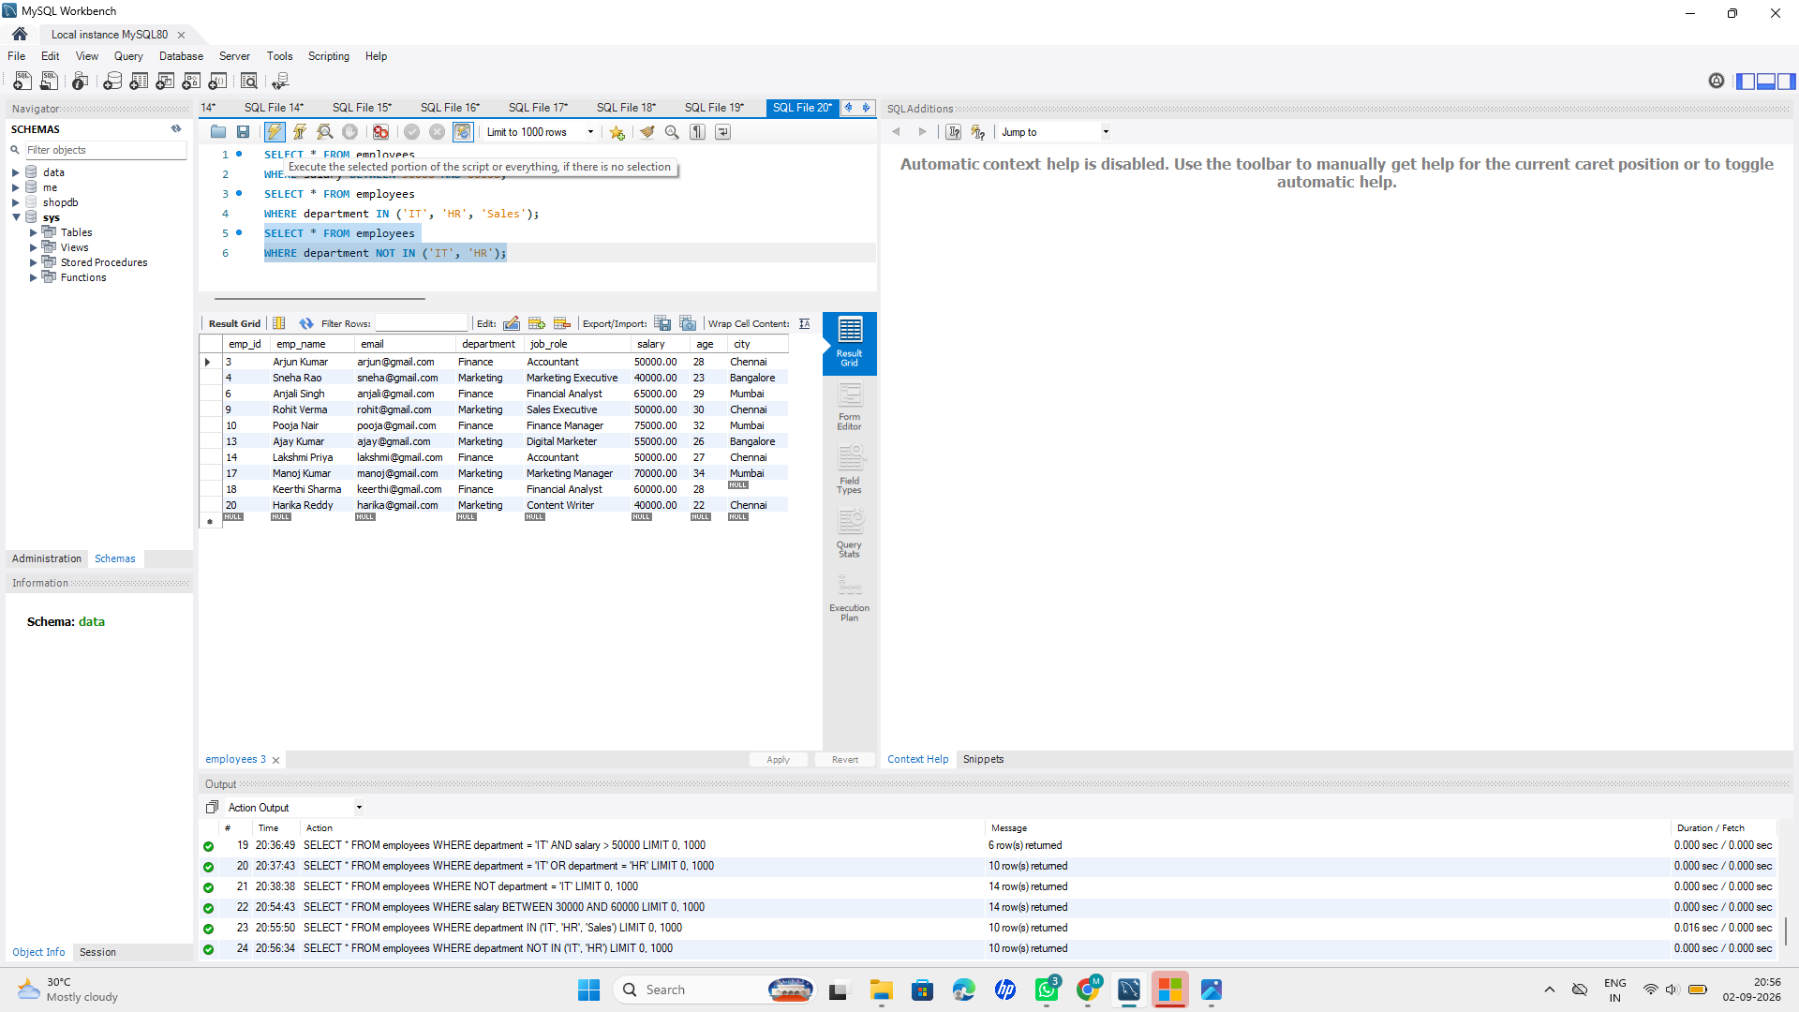
4. SELECT * FROM employees
WHERE emp_name LIKE 'A%';
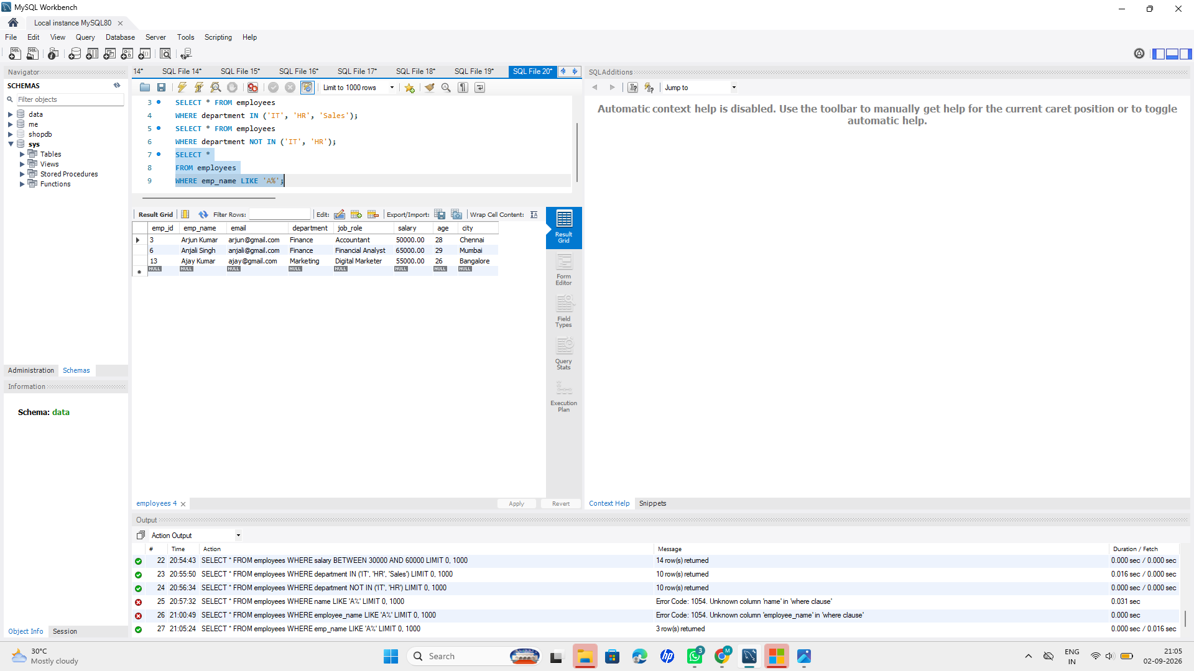

5. SELECT * FROM employees
WHERE city IS NULL;
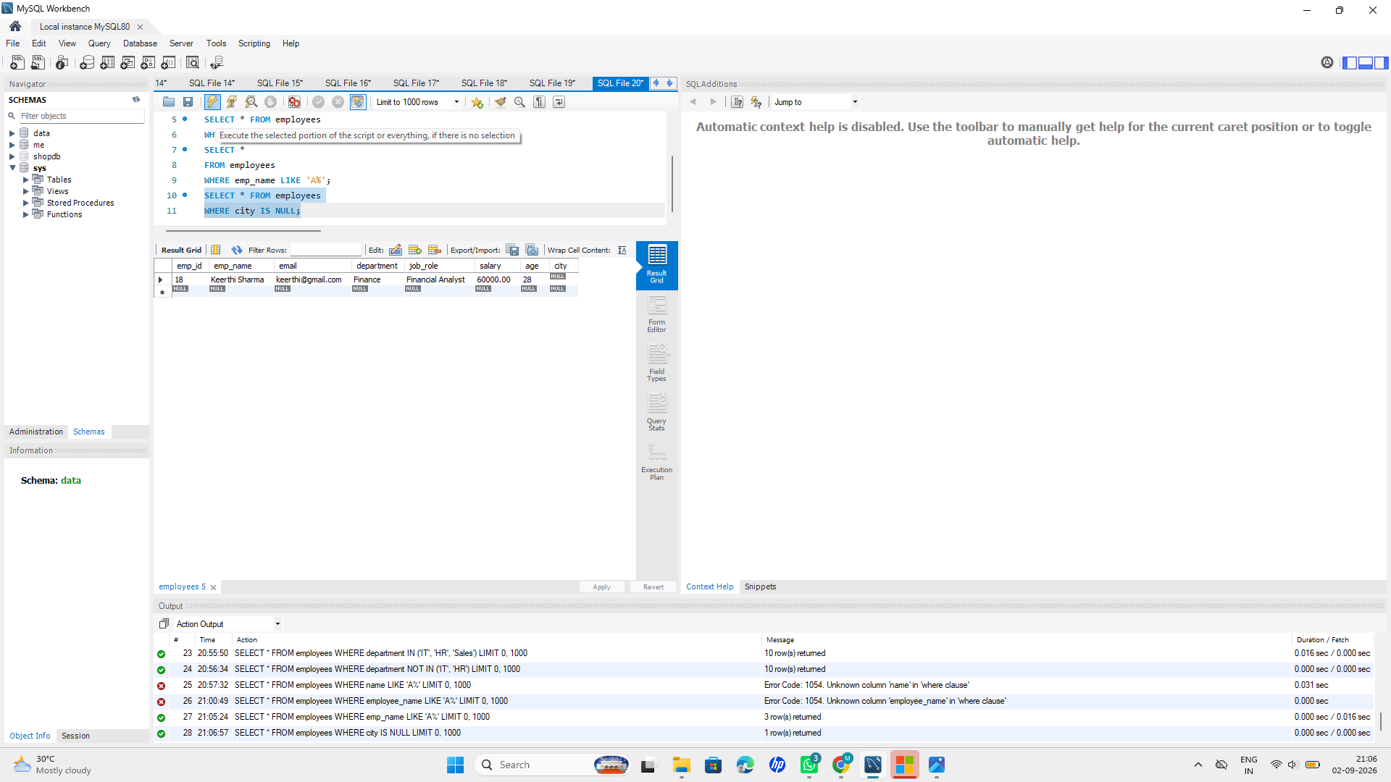

6. SELECT * FROM employees
WHERE city IS NOT NULL;
OUTPUT:

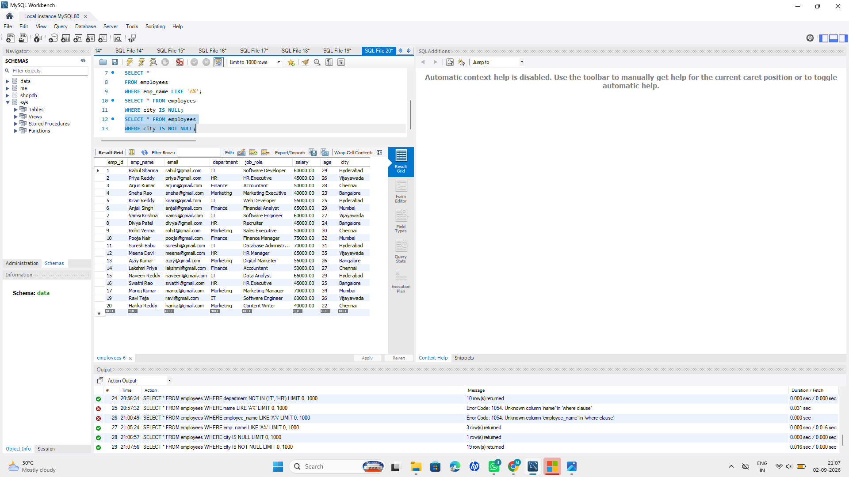

Stage 7 — ORDER BY
Sort employee records using ORDER BY.
1. Sort employees by salary in ascending order.
Query:
SELECT * FROM employees
ORDER BY salary ASC;
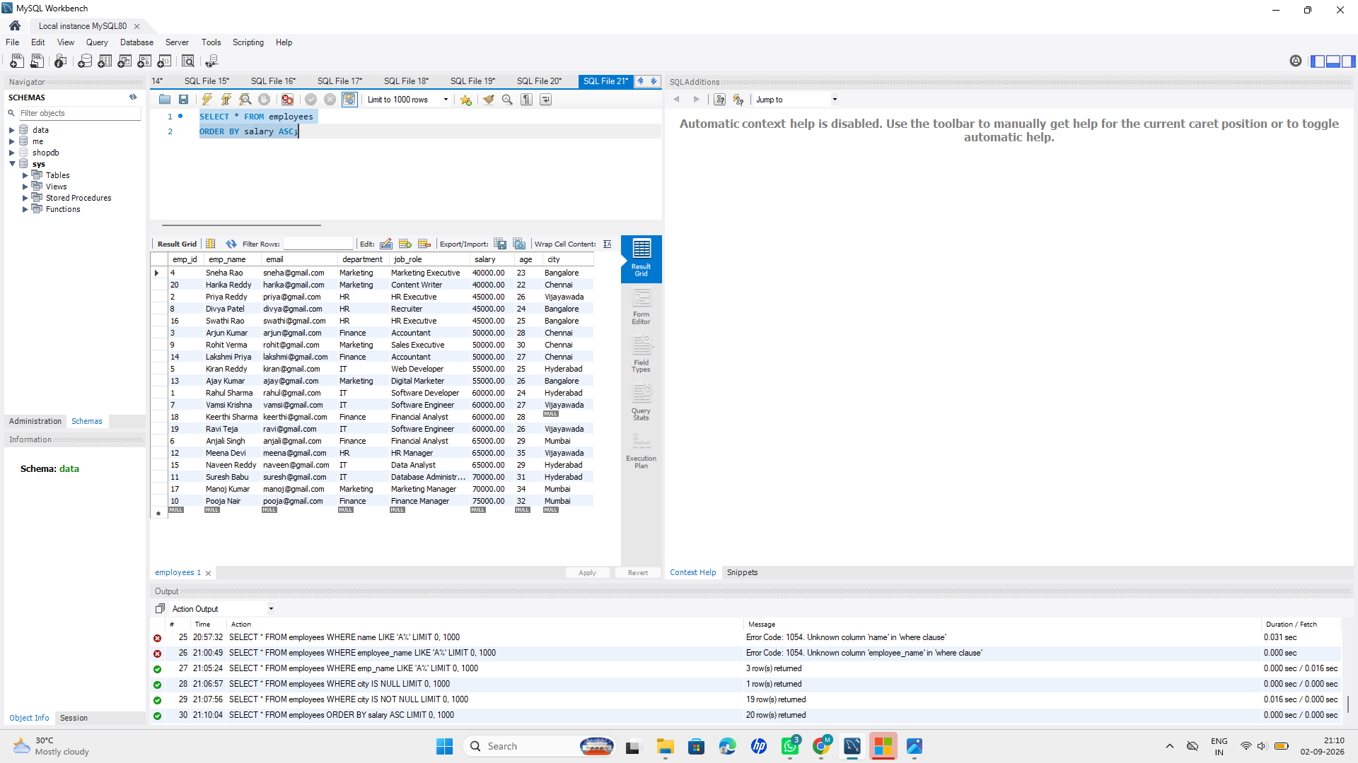
2. Sort employees by salary in descending order.
Query:
SELECT * FROM employees
ORDER BY salary DESC;
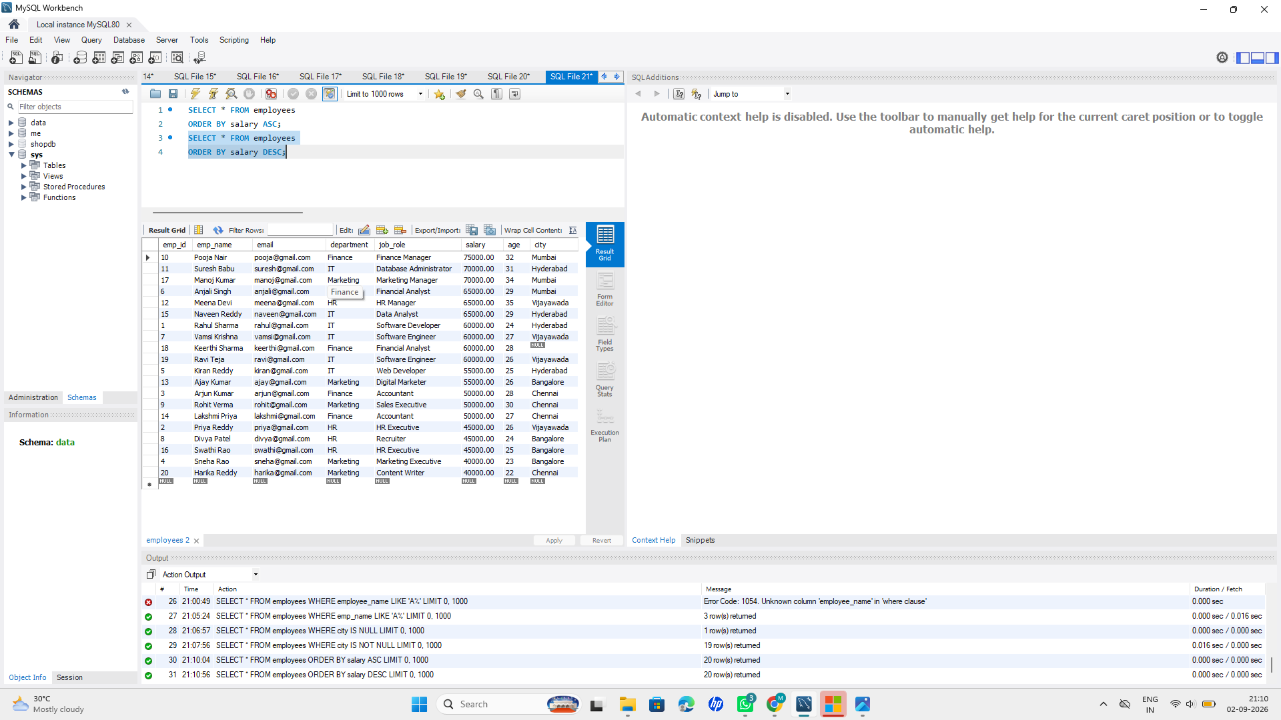
3. Sort employees by age.
Query:
SELECT * FROM employees
ORDER BY age ASC;
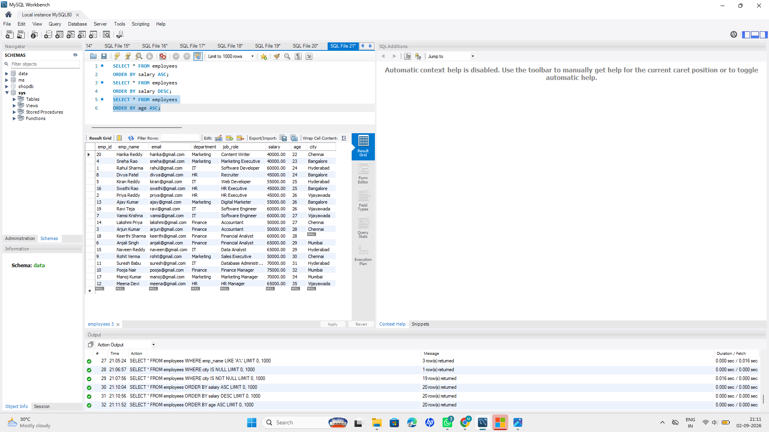
4. Sort employees by department.
Query:
SELECT * FROM employees
ORDER BY department ASC;
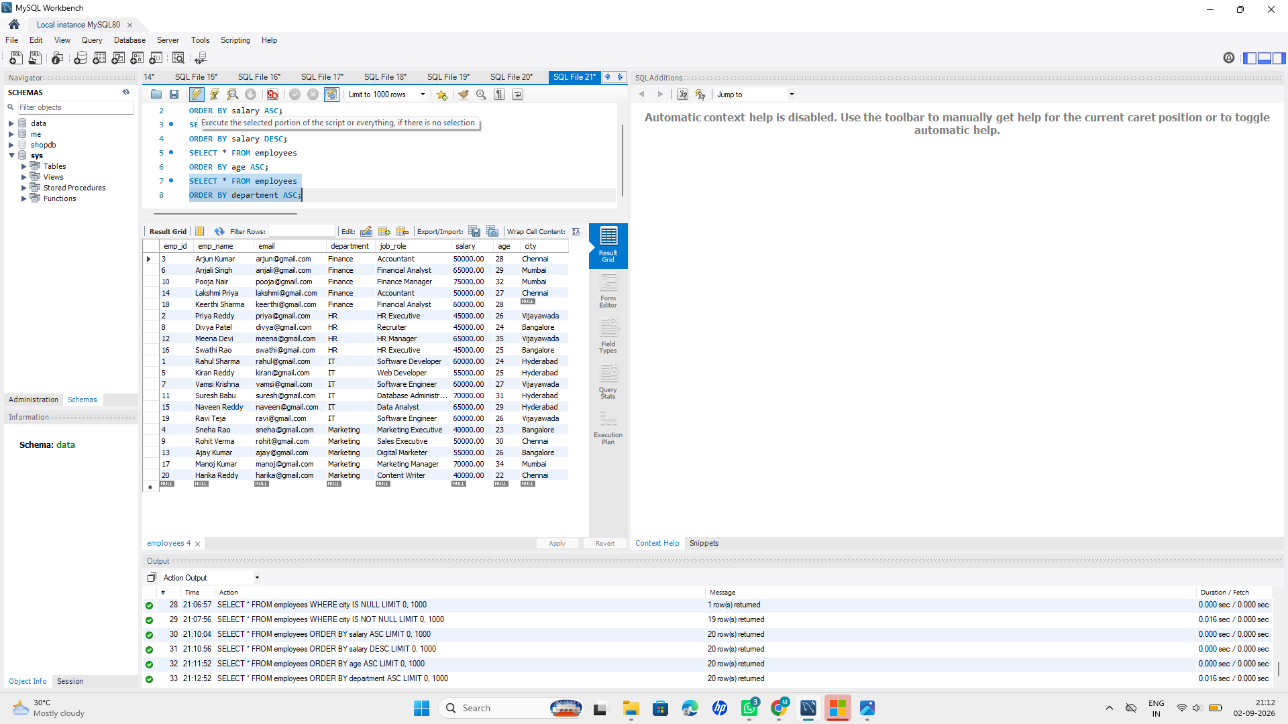
5. Sort employees by multiple columns.
Query:
SELECT * FROM employees
ORDER BY department ASC, salary DESC;
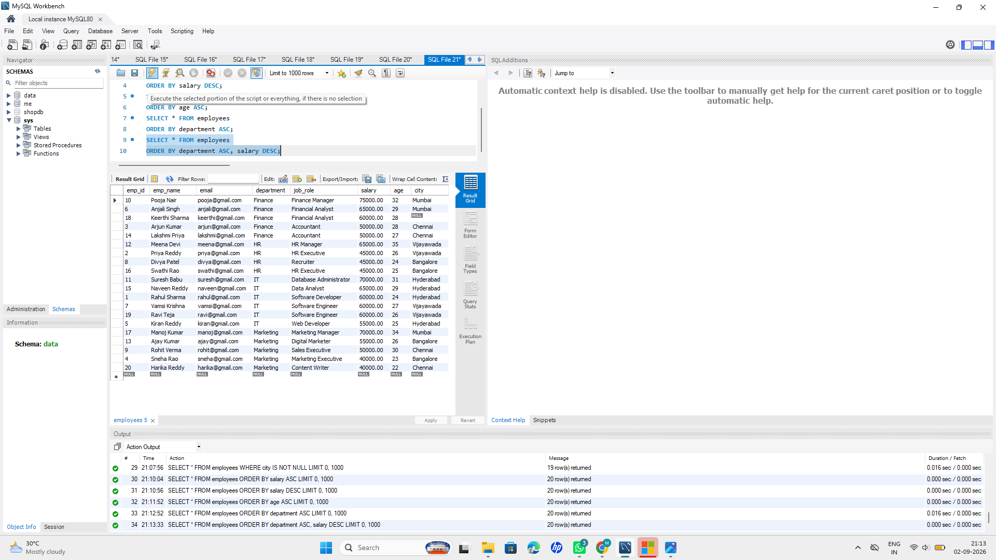
6. Practice both ASC and DESC.
Query:
SELECT * FROM employees
ORDER BY age ASC, salary DESC;

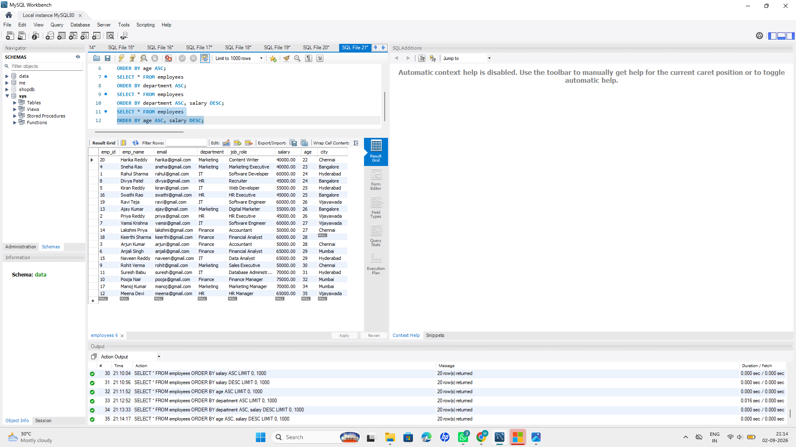
Stage 8: Aggregate Functions
Practice the following aggregate functions:
1. COUNT() – Count employees.
Query:
SELECT COUNT(*) AS total_employees
FROM employees;
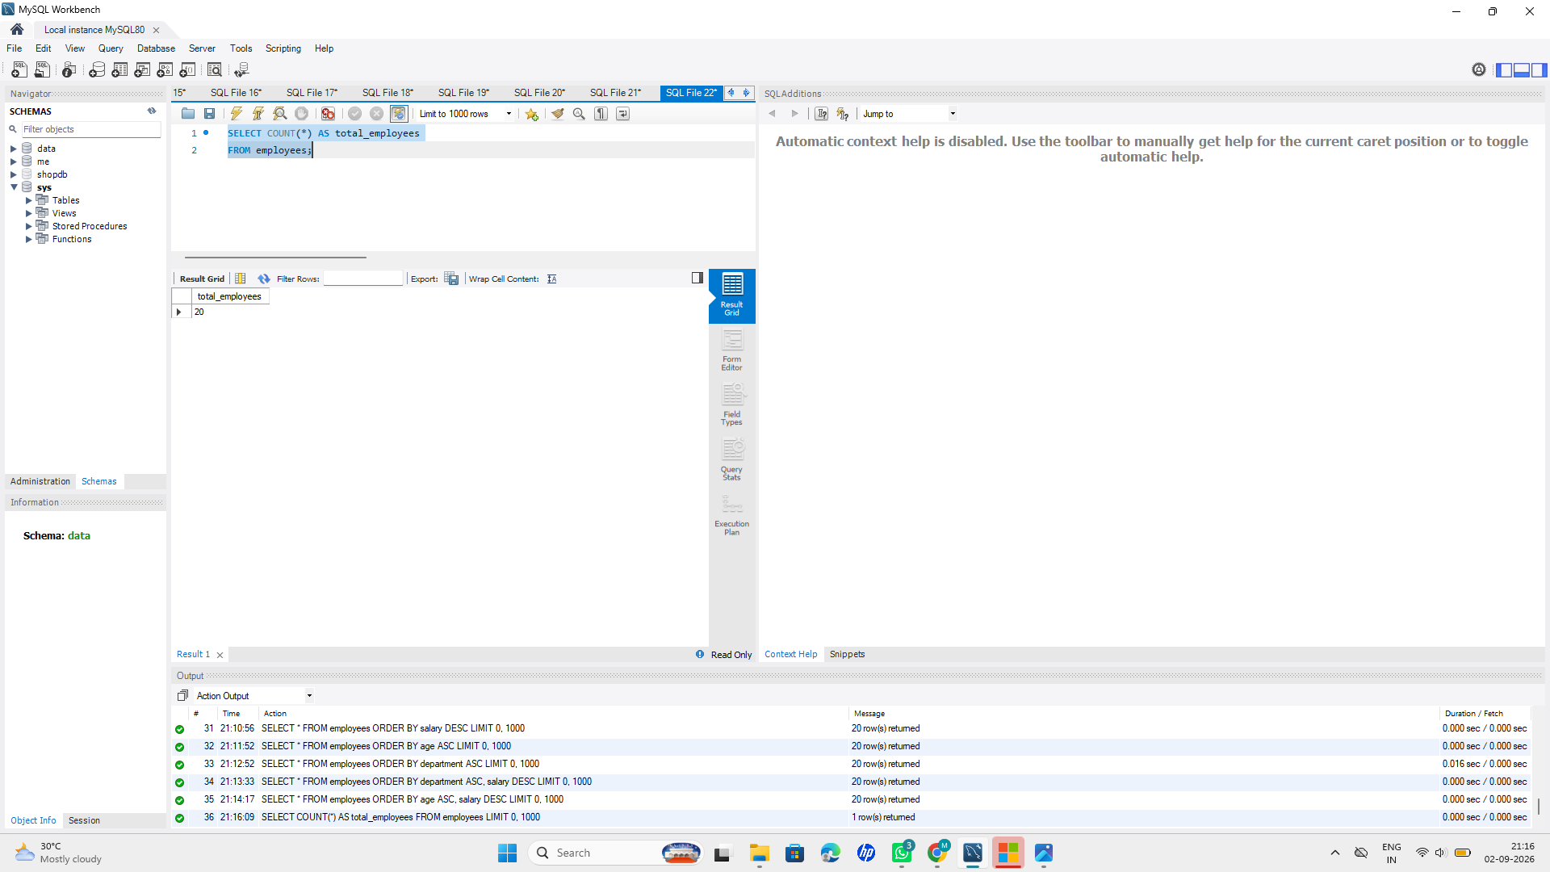
2. SUM() – Calculate total salary.
Query:
SELECT SUM(salary) AS total_salary
FROM employees;
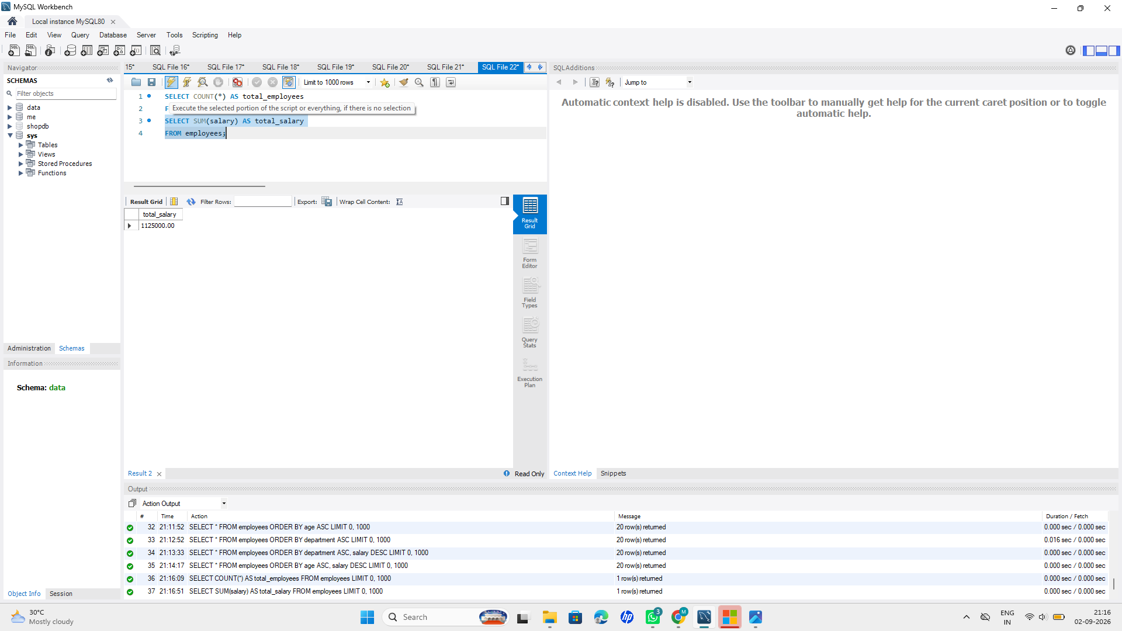
3. AVG() – Calculate average salary.
Query:
SELECT AVG(salary) AS average_salary
FROM employees;
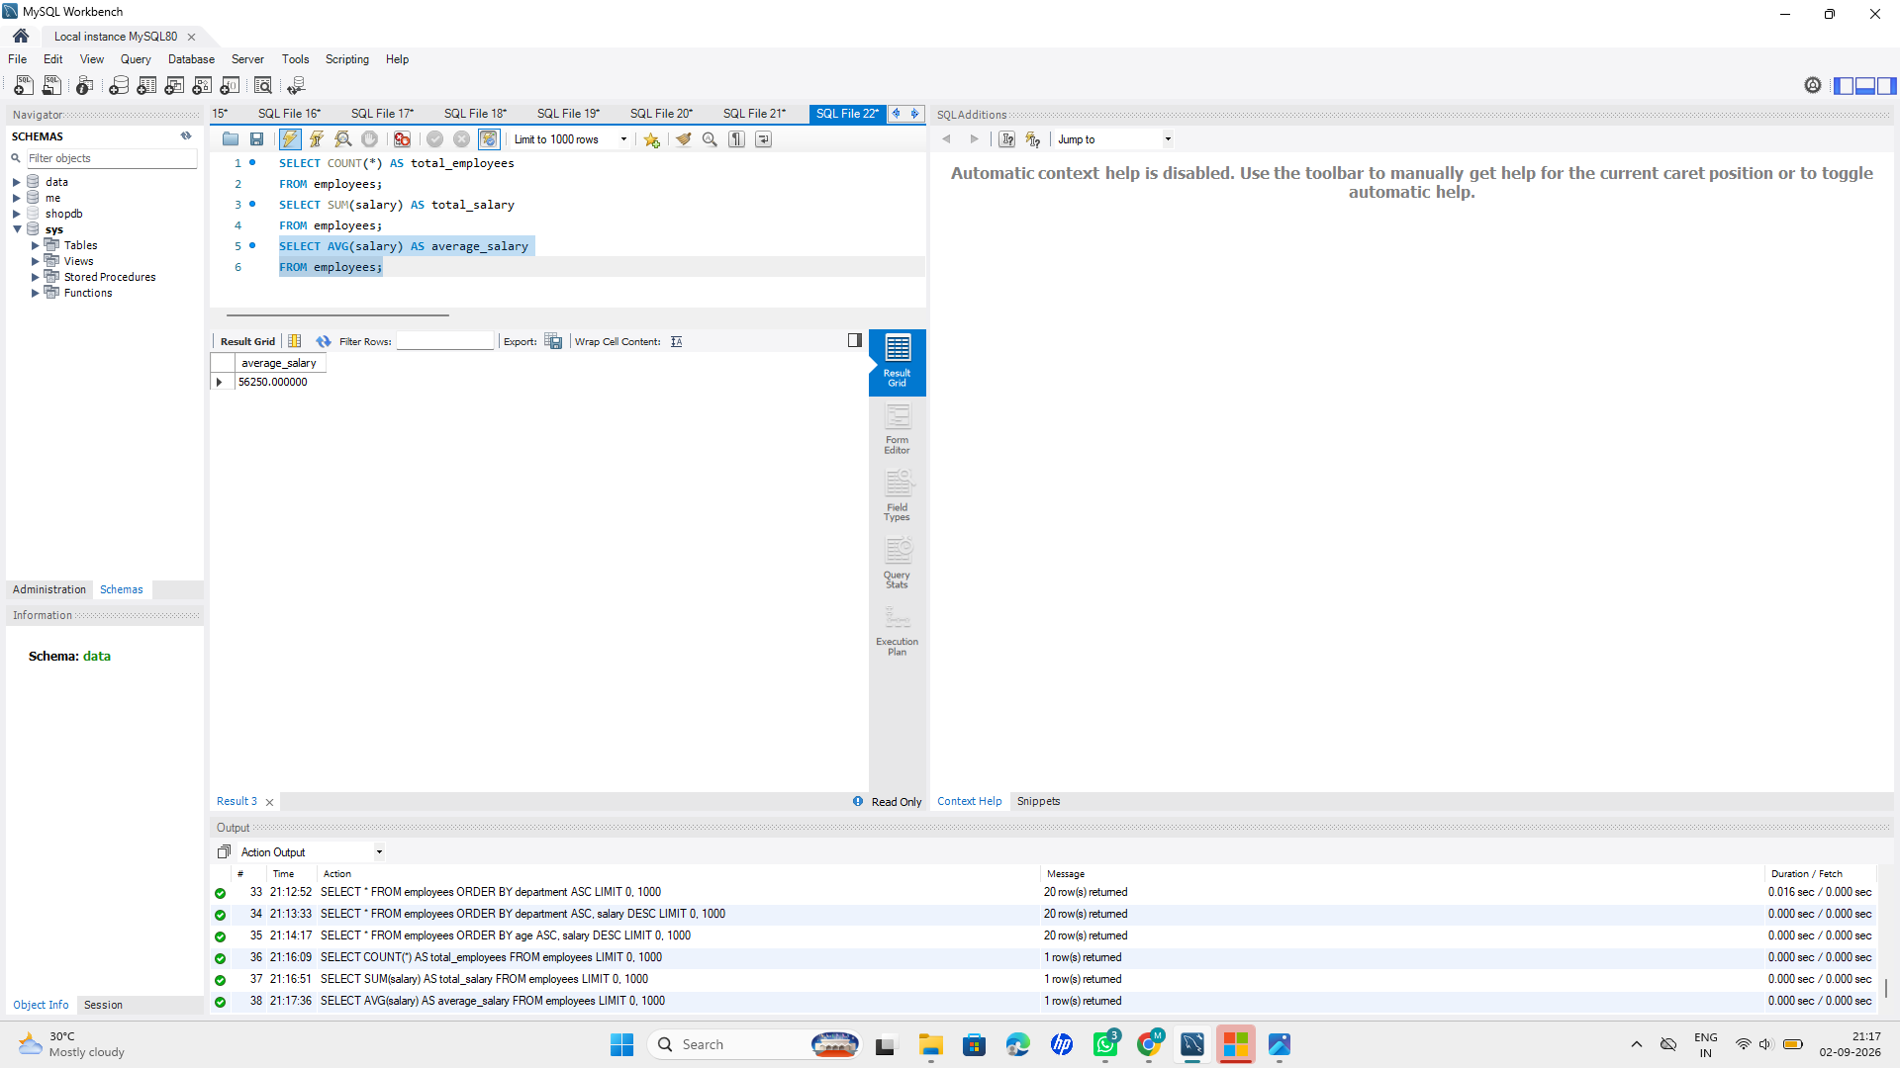
4. MIN() – Find the lowest salary.
Query:
SELECT MIN(salary) AS minimum_salary
FROM employees;
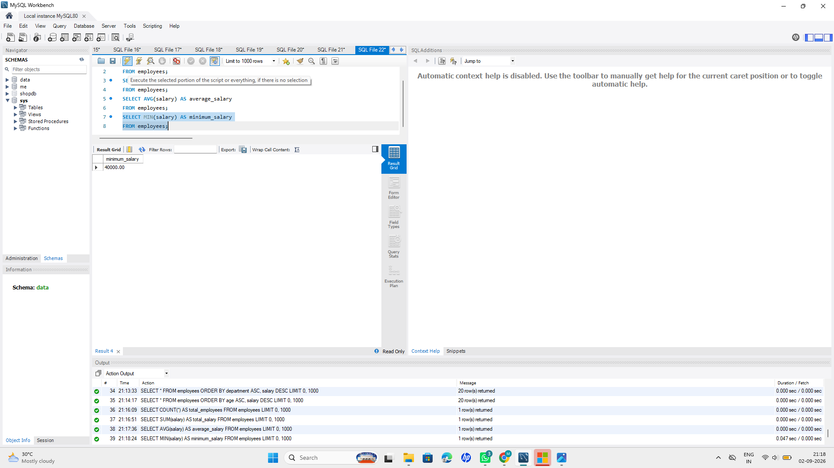
5. MAX() – Find the highest salary.
Query:
SELECT MAX(salary) AS maximum_salary
FROM employees;
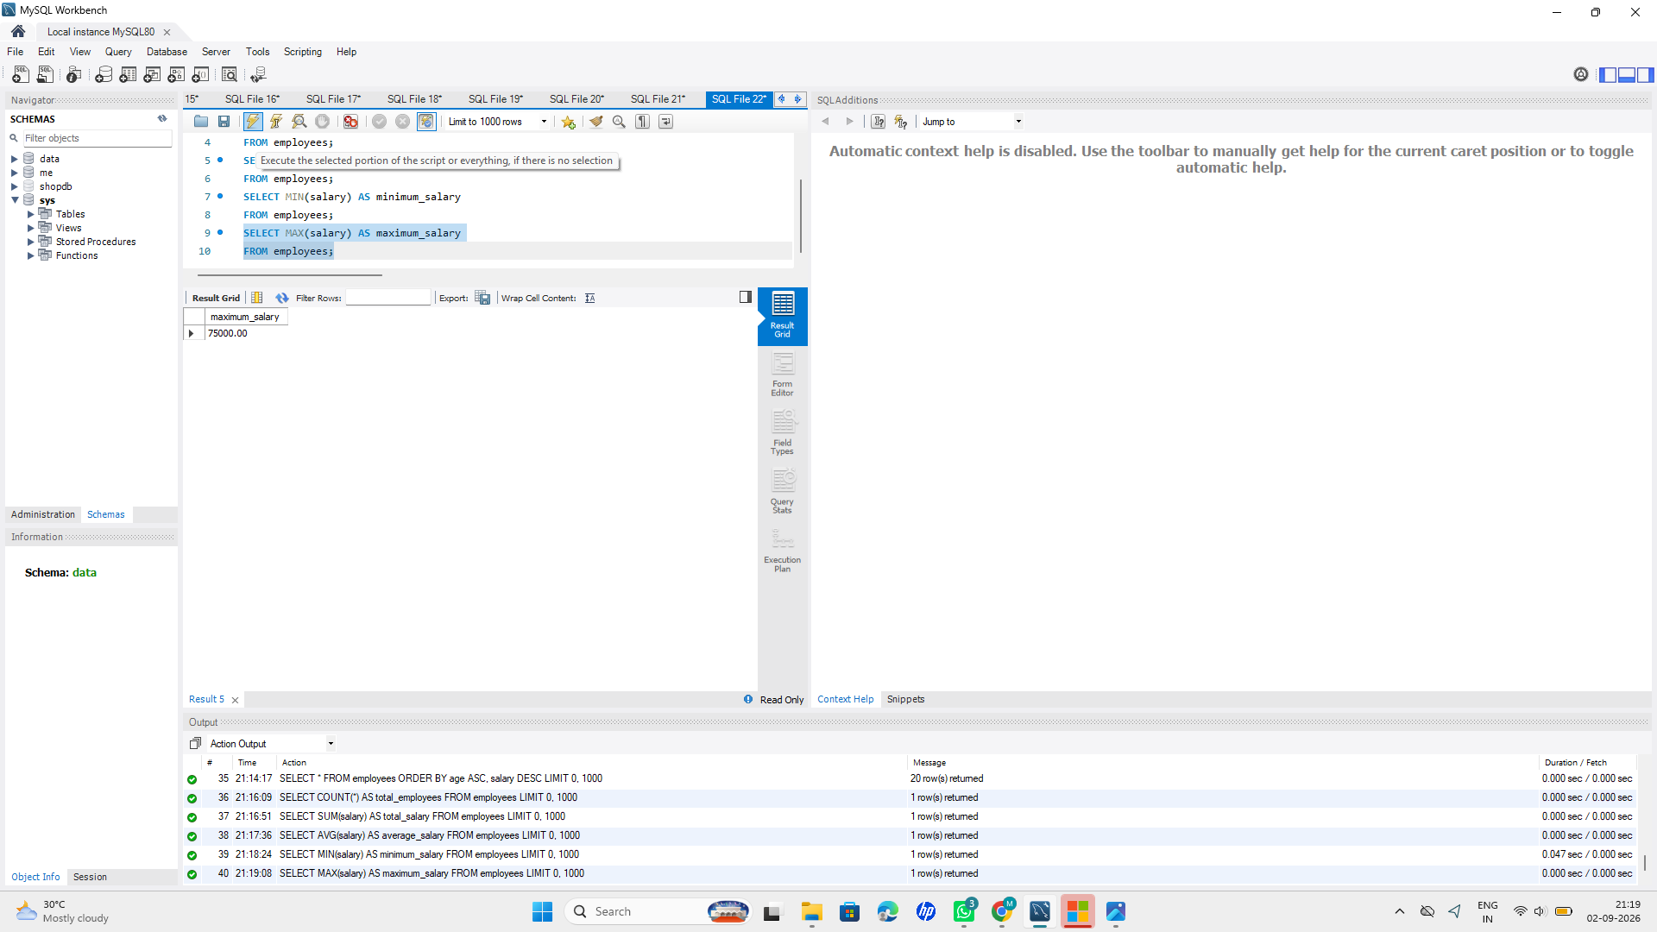
Stage 9 — GROUP BY
1. Count employees in each department
Query:
SELECT department, COUNT(*) AS employee_count
FROM employees
GROUP BY department;
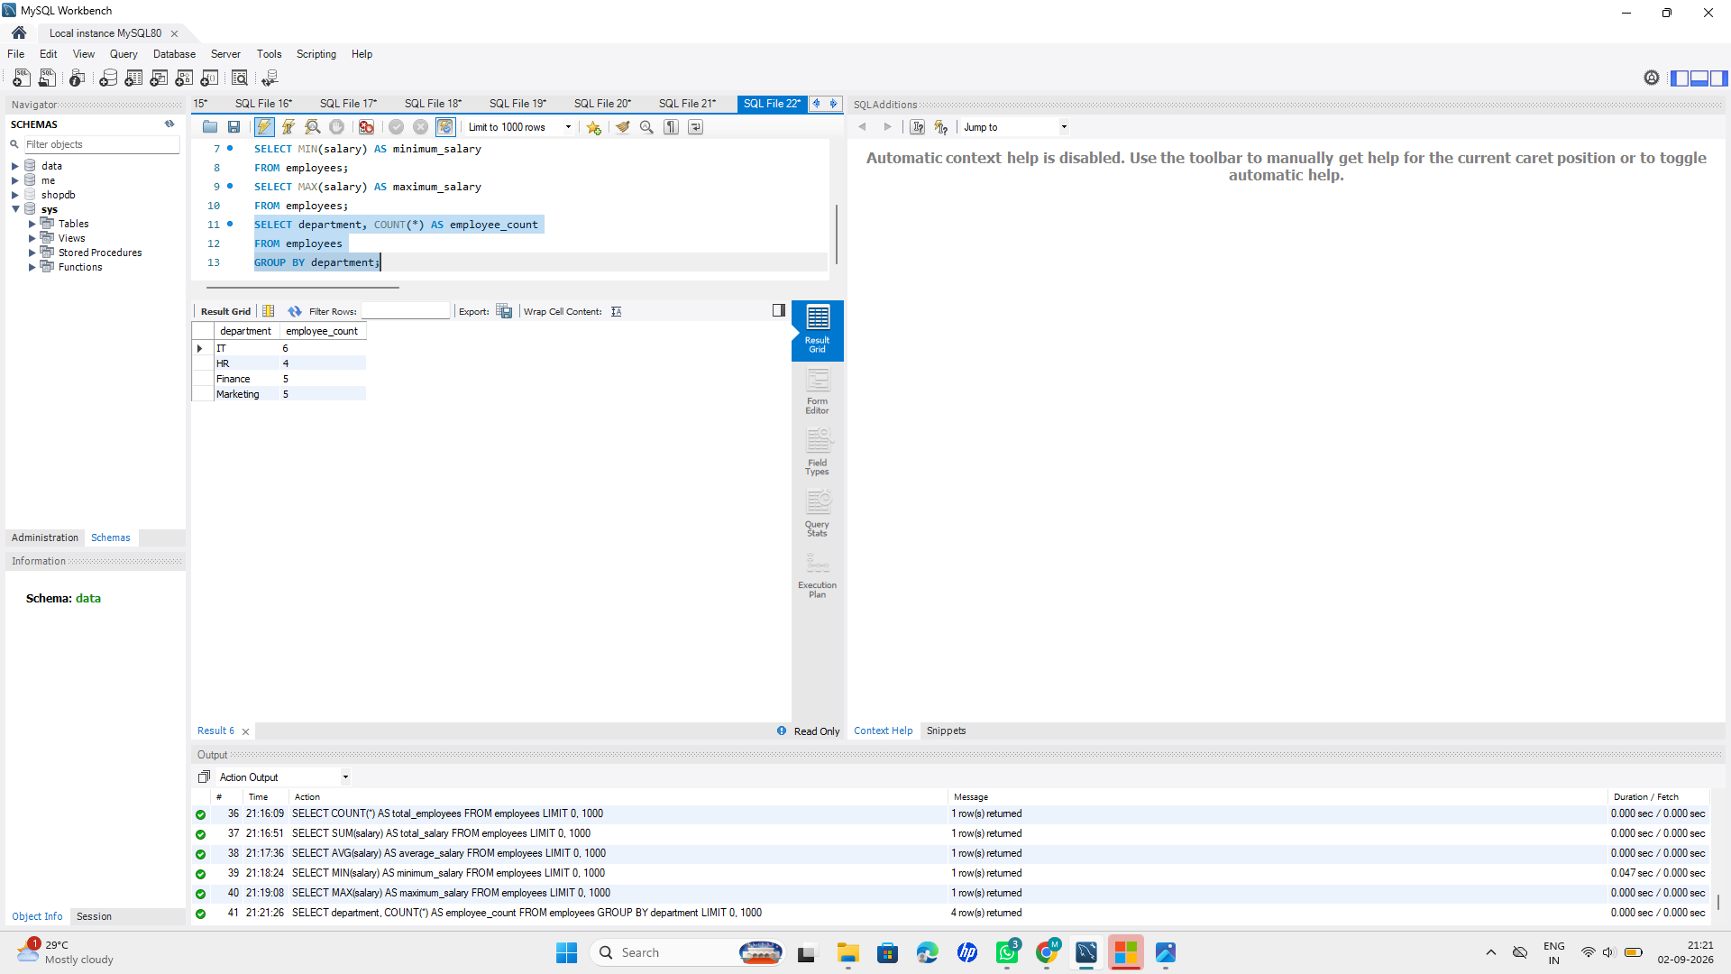
2. Find average salary in each department
Query:
SELECT department, AVG(salary) AS average_salary
FROM employees
GROUP BY department;
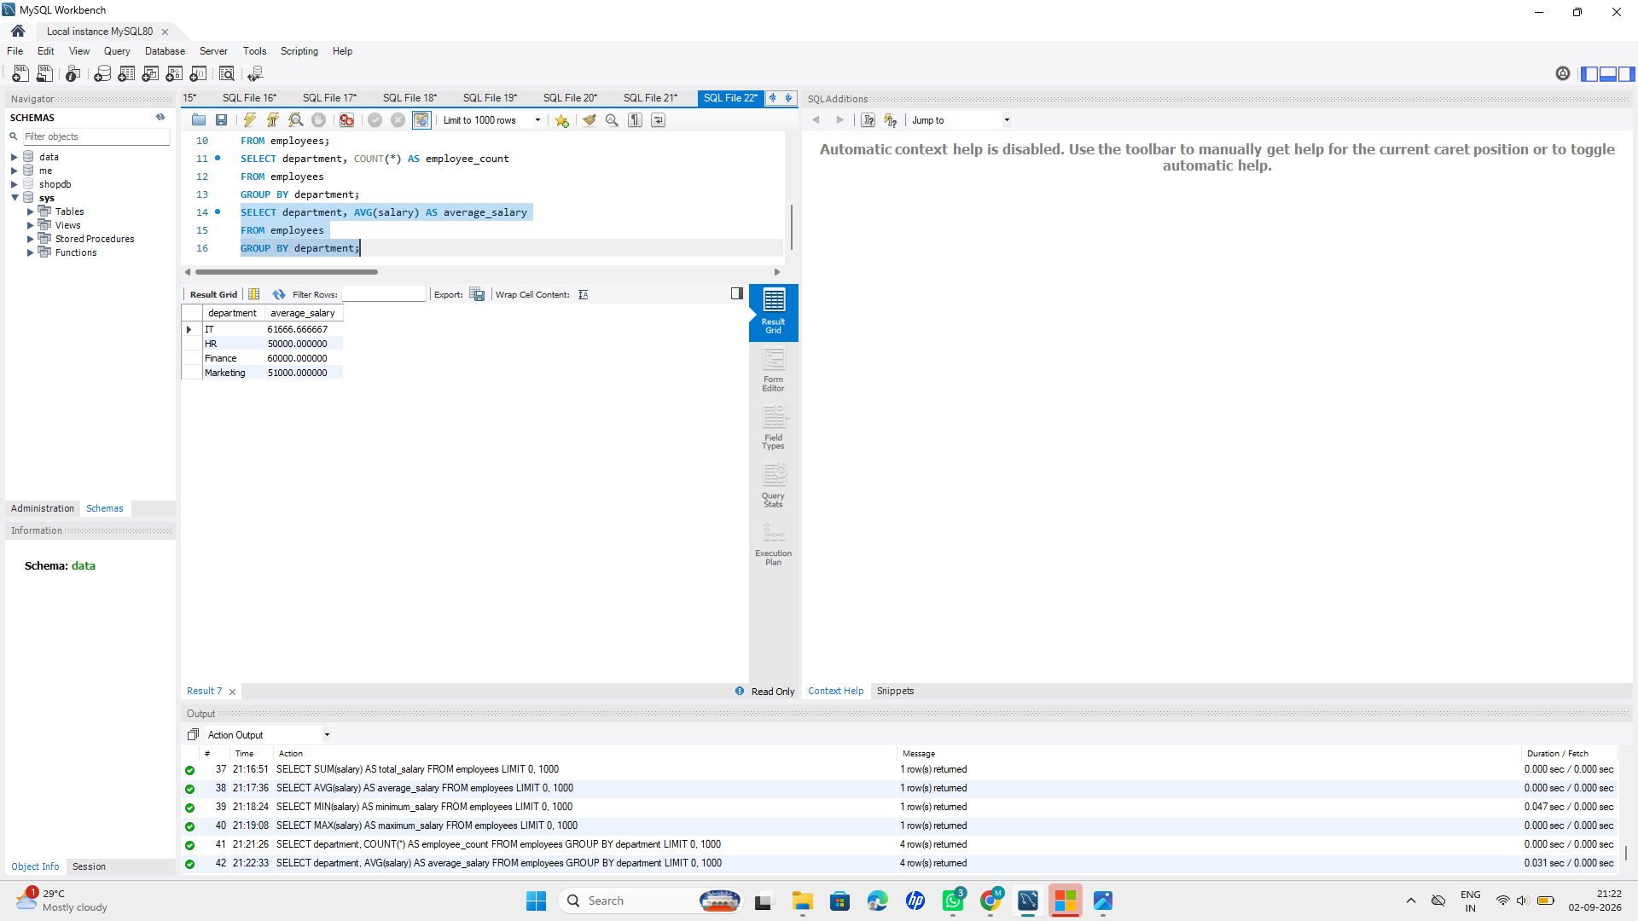
3. Find minimum salary in each department
Query:
SELECT department, MIN(salary) AS minimum_salary
FROM employees
GROUP BY department;
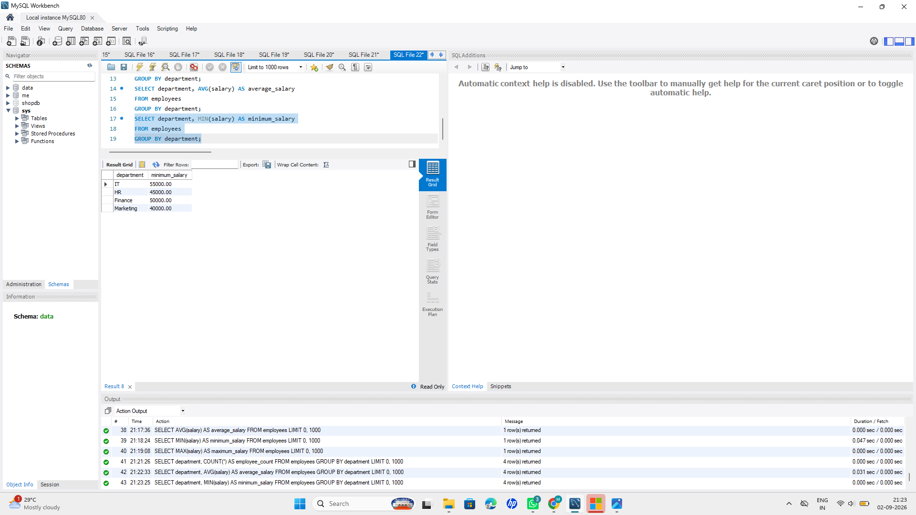
4. Find maximum salary in each department
Query:
SELECT department, MAX(salary) AS maximum_salary
FROM employees
GROUP BY department;
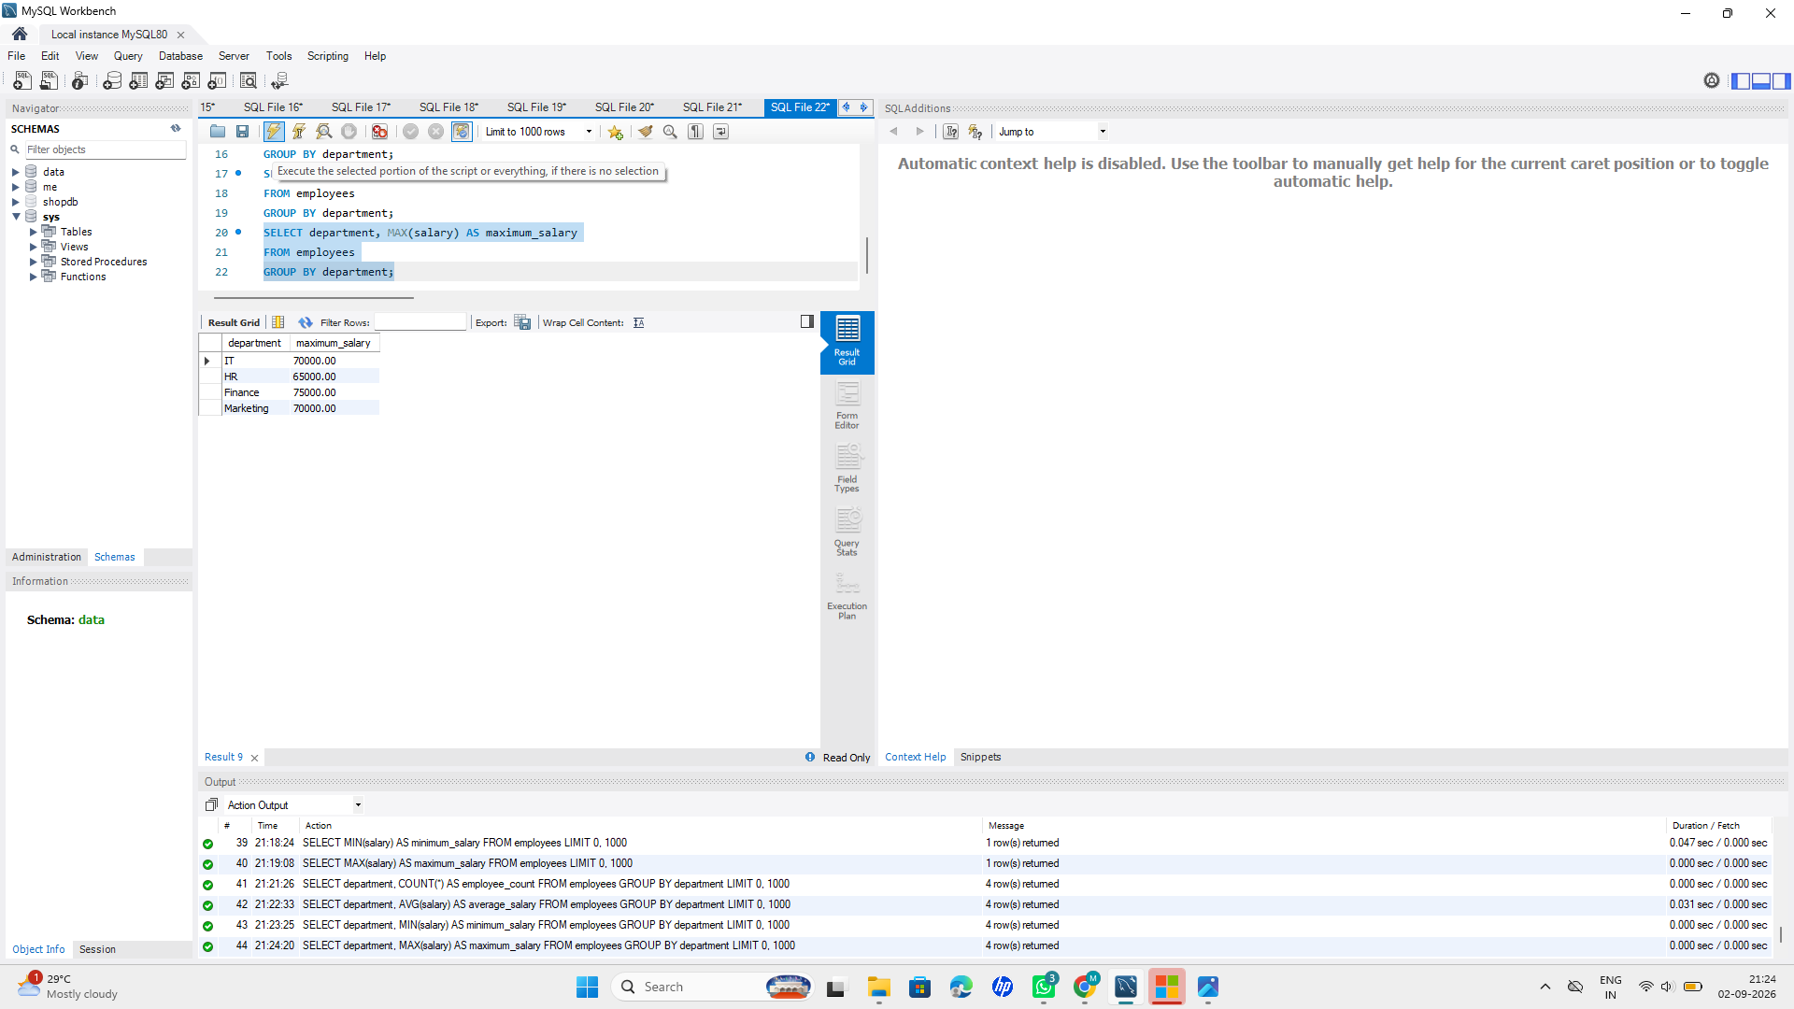
5. Find total salary in each department
Query:
SELECT department, SUM(salary) AS total_salary
FROM employees
GROUP BY department;
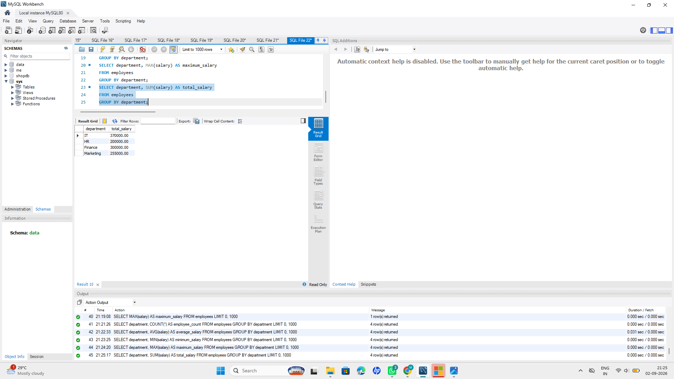
6. Count employees in each city
Query:
SELECT city, COUNT(*) AS employee_count
FROM employees
GROUP BY city;
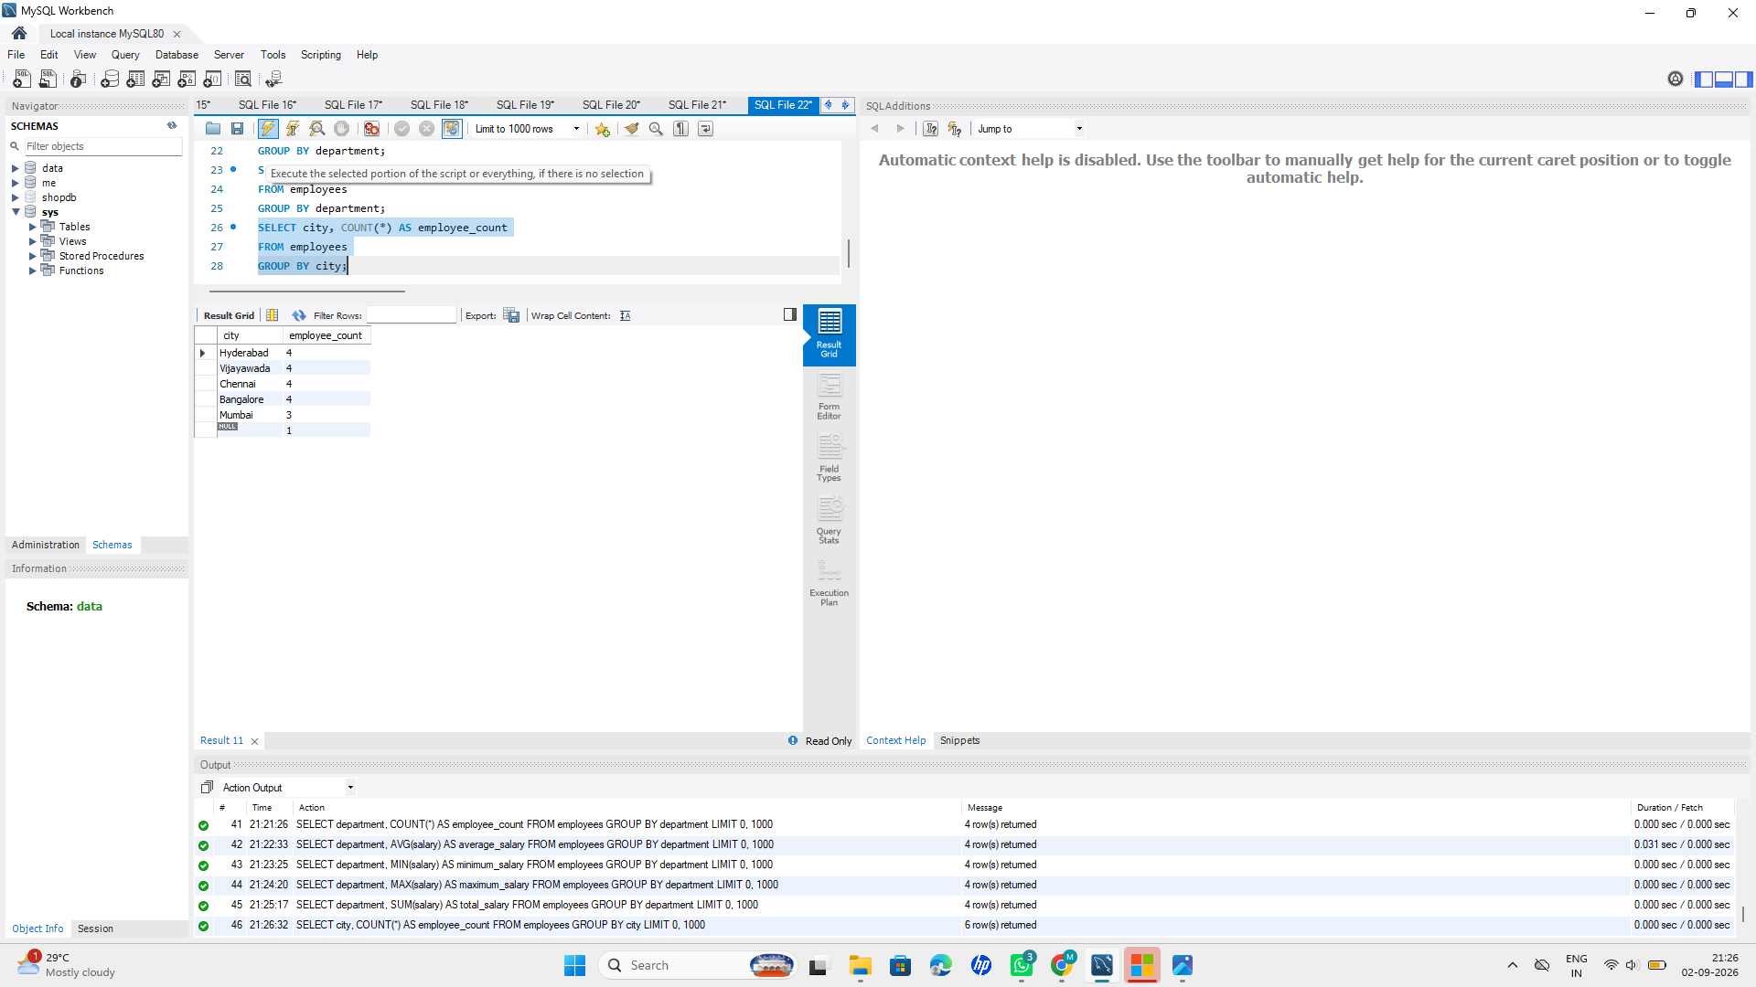
7. Find average salary in each city
Query:
SELECT city, AVG(salary) AS average_salary
FROM employees
GROUP BY city;
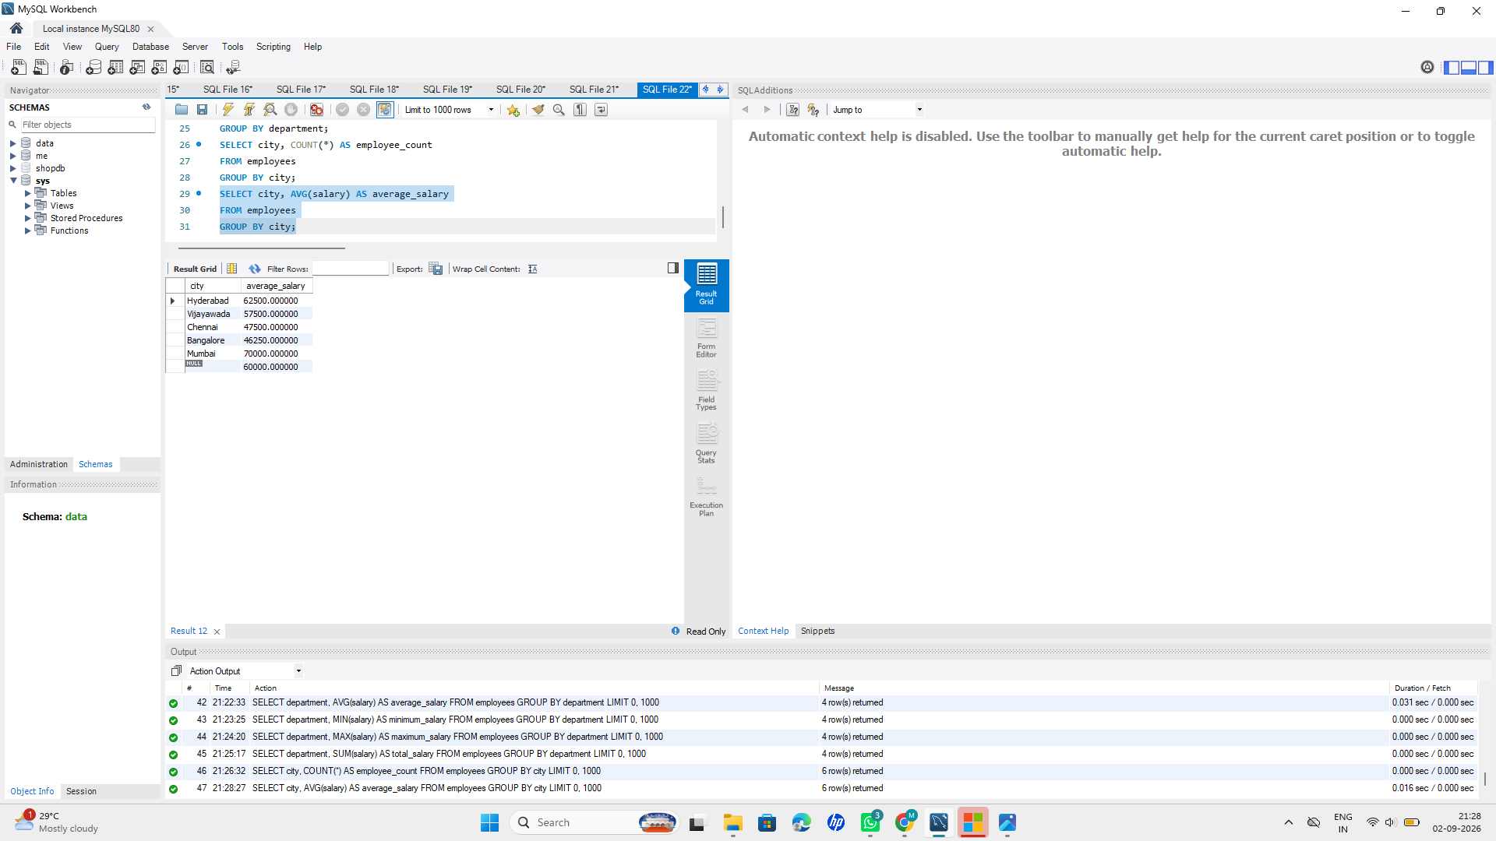
8. Find maximum salary in each city
Query:
SELECT city, MAX(salary) AS maximum_salary
FROM employees
GROUP BY city;
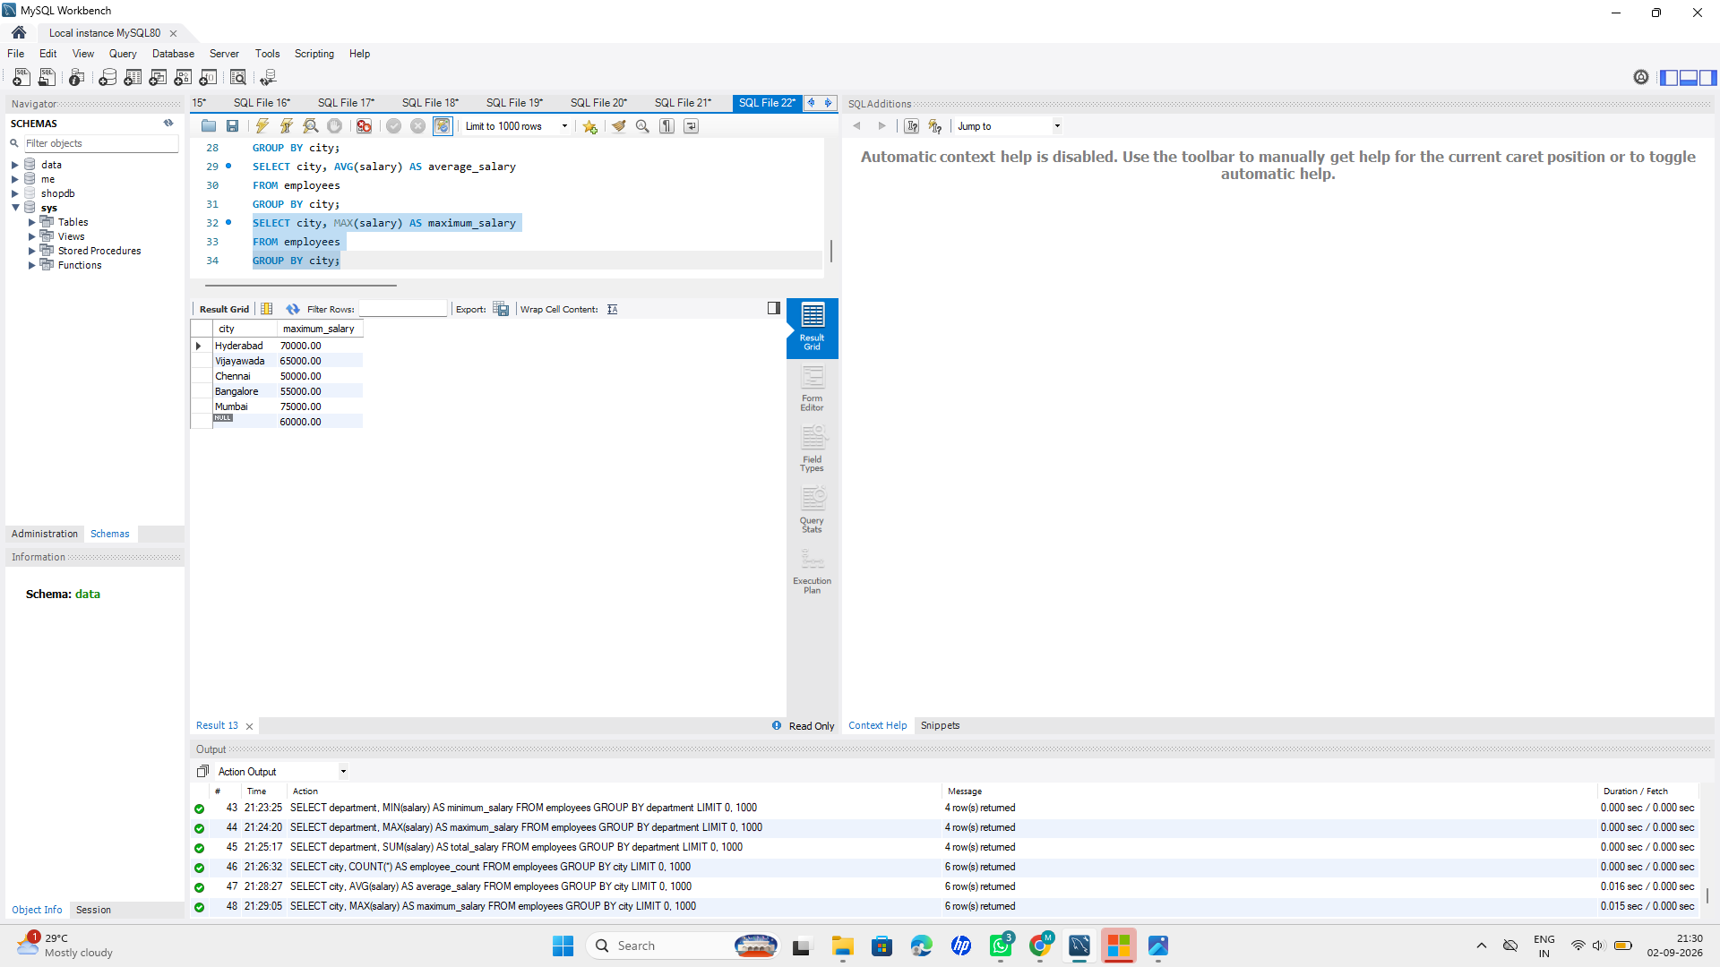
Stage 10 — HAVING
1. Find departments having more than 3 employees
Query:
SELECT department, COUNT(*) AS employee_count
FROM employees
GROUP BY department
HAVING COUNT(*) > 3;
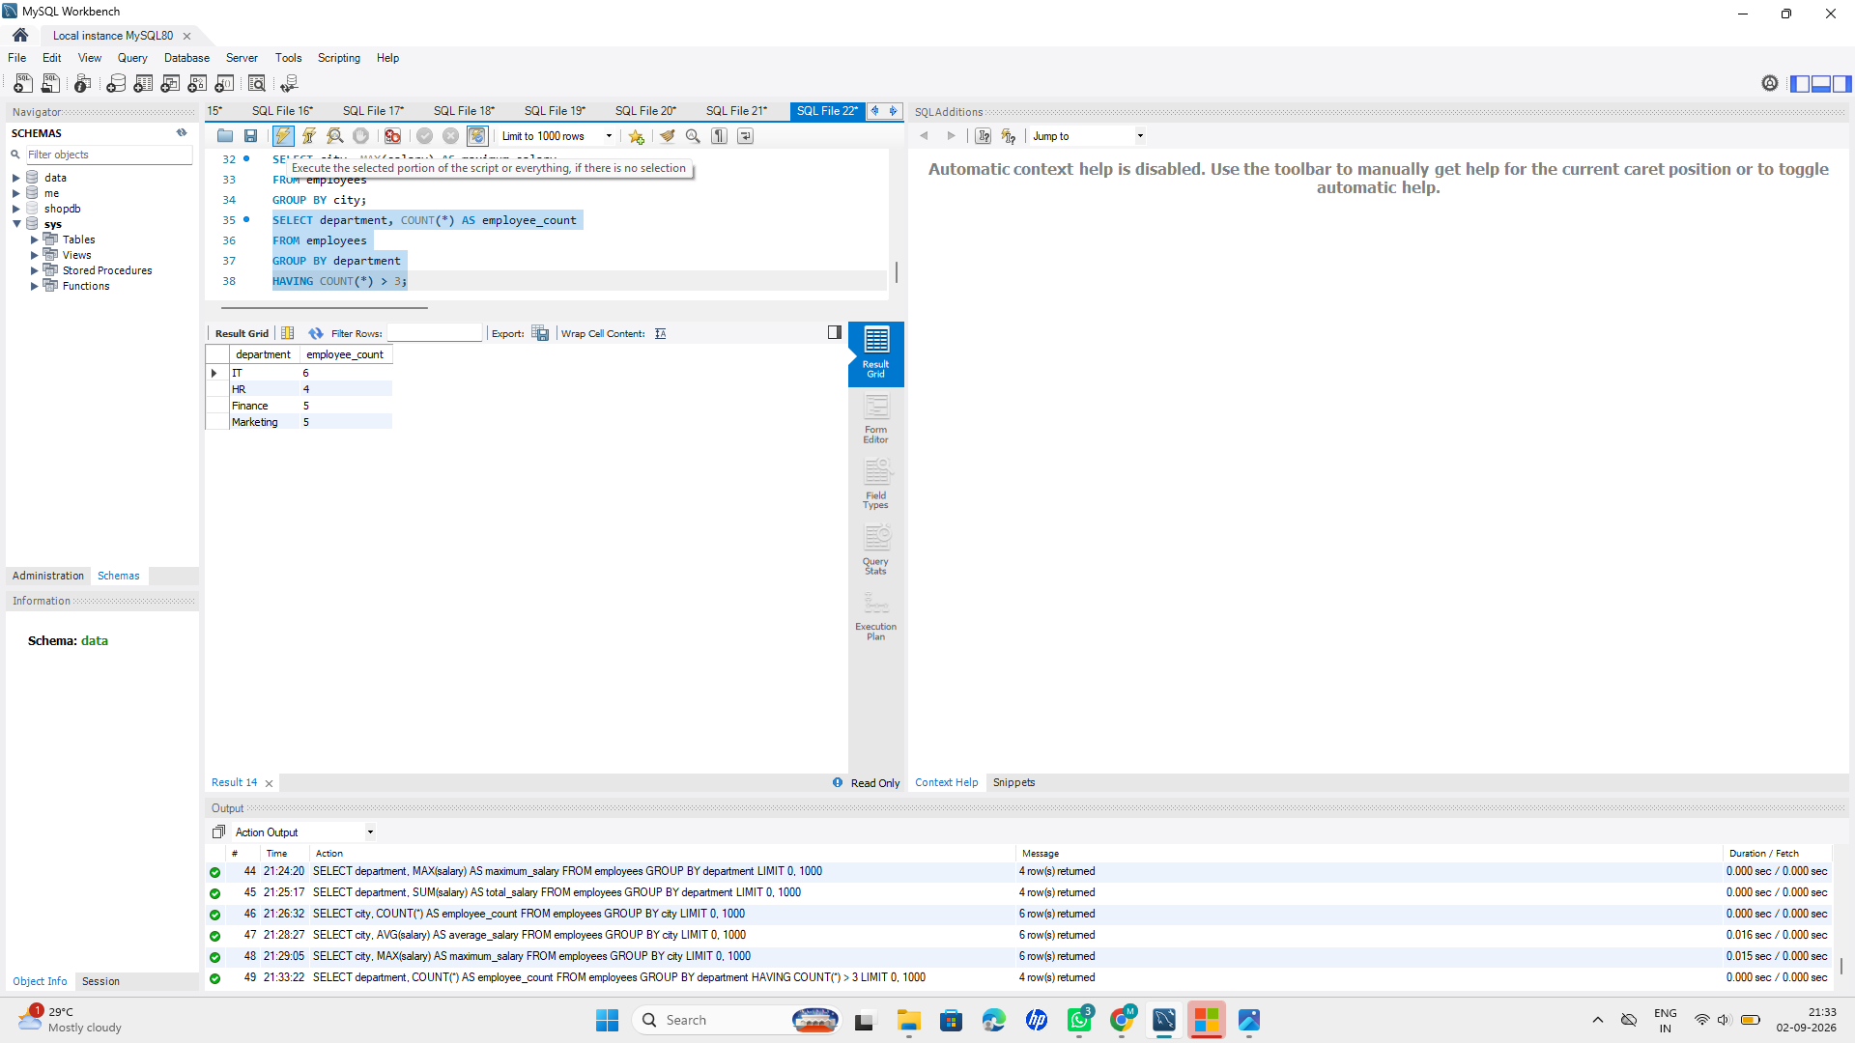
2. Find departments with average salary above 60000
Query:
SELECT department, AVG(salary) AS average_salary
FROM employees
GROUP BY department
HAVING AVG(salary) > 60000;
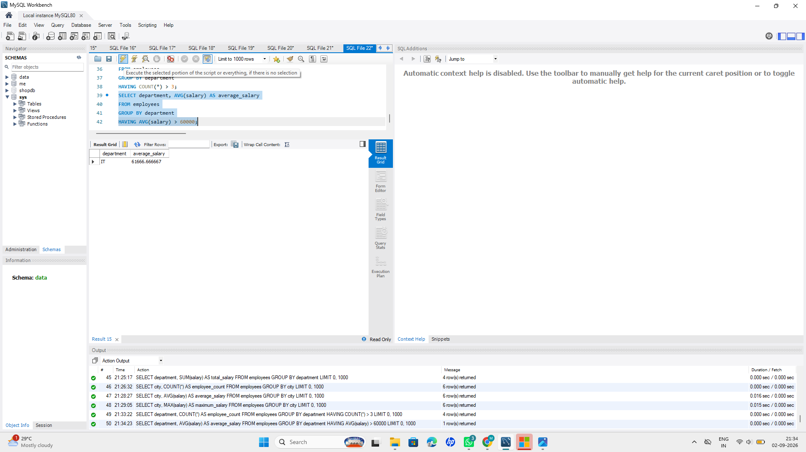
3. Find cities having more than 3 employees
Query:
SELECT city, COUNT(*) AS employee_count
FROM employees
GROUP BY city
HAVING COUNT(*) > 3;
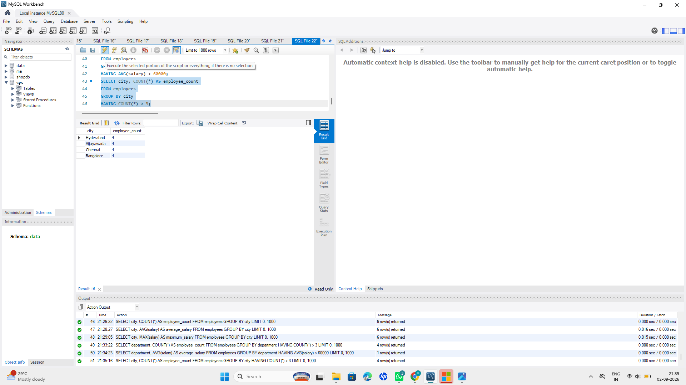
4. Find departments where maximum salary is above 70000
Query:
SELECT department, MAX(salary) AS maximum_salary
FROM employees
GROUP BY department
HAVING MAX(salary) > 70000;
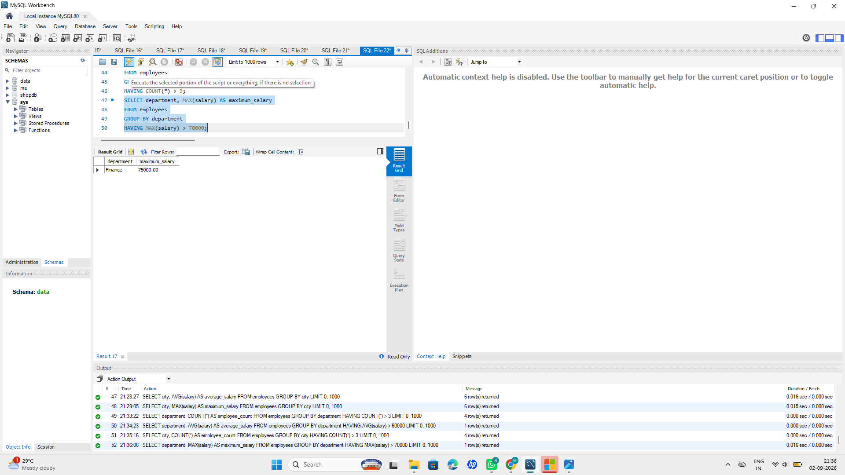

Stage 11: Challenge Questions
Solve the following using SQL:
1. Find the second-highest salary.
Query:
SELECT MAX(salary) AS second_highest_salary
FROM employees
WHERE salary < (SELECT MAX(salary) FROM employees);
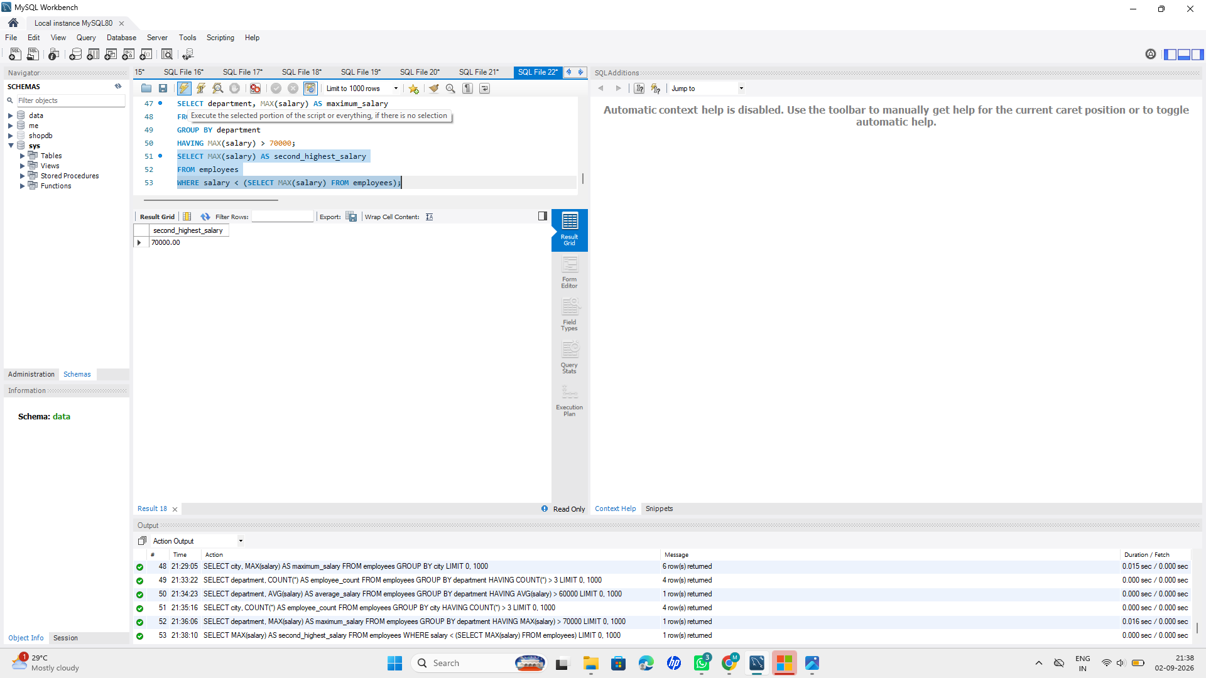
2. Find employees earning above the average salary.
Query:
SELECT * FROM employees
WHERE salary > (SELECT AVG(salary) FROM employees);
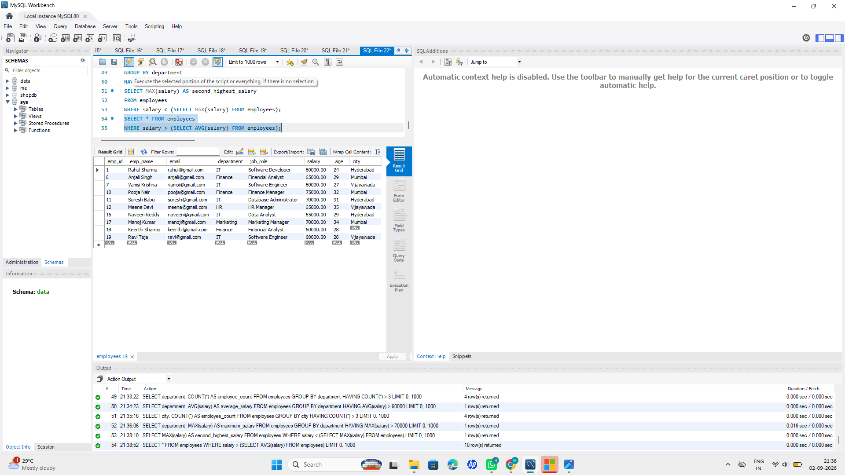
3. Find the employee(s) with the highest salary.
Query:
SELECT * FROM employees
WHERE salary = (SELECT MAX(salary) FROM employees);
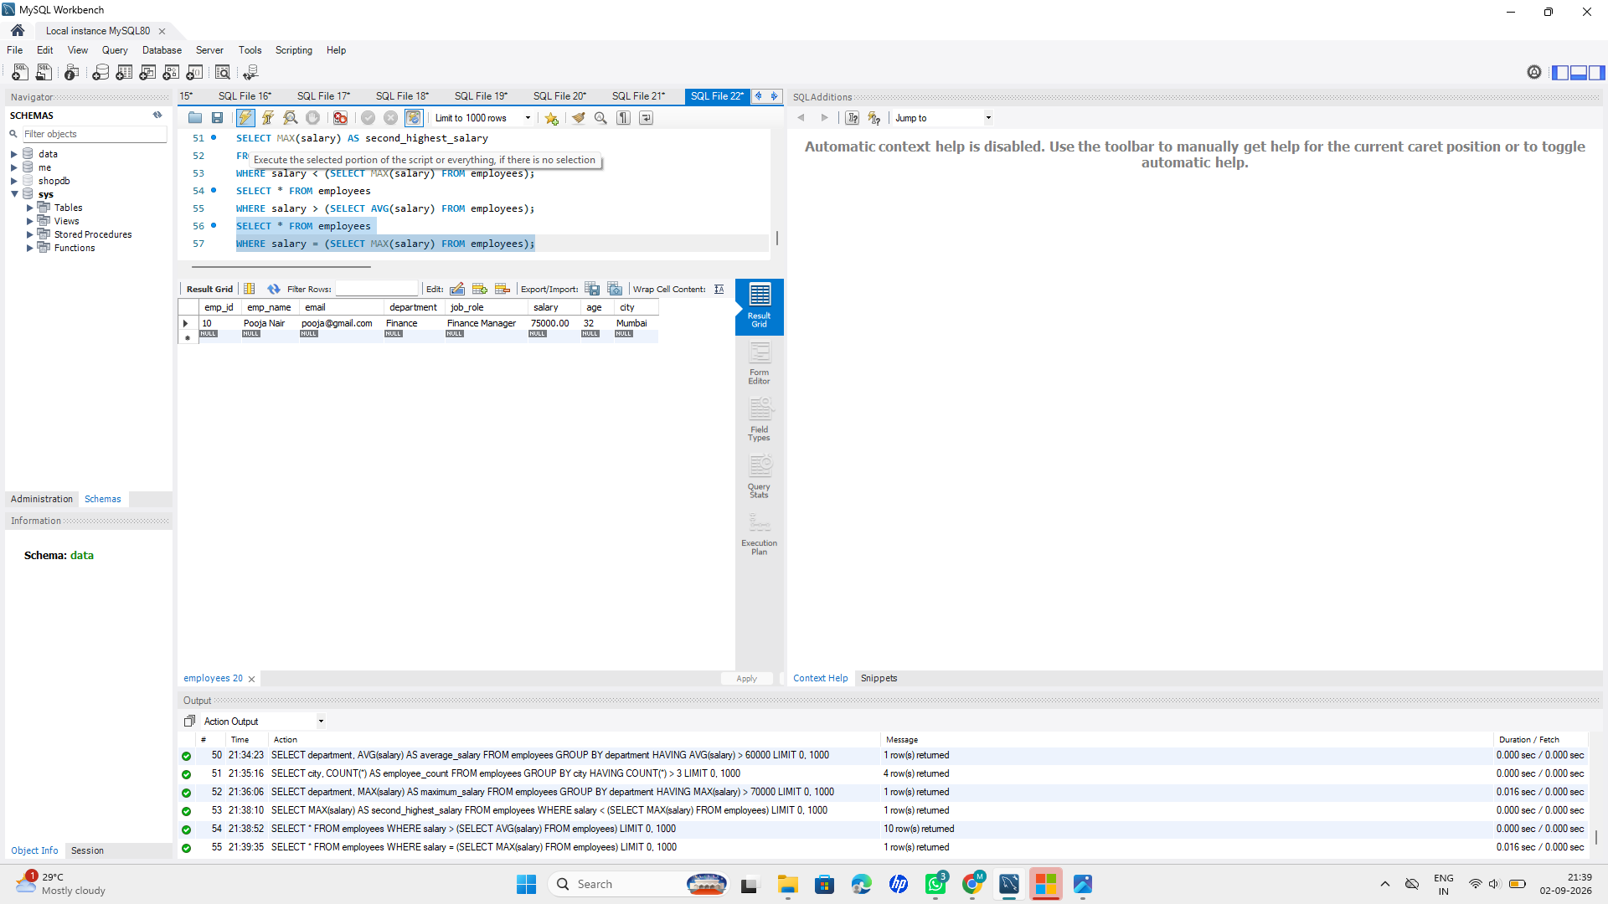
4. Find the employee(s) with the lowest salary.
Query:
SELECT * FROM employees
WHERE salary = (SELECT MIN(salary) FROM employees);
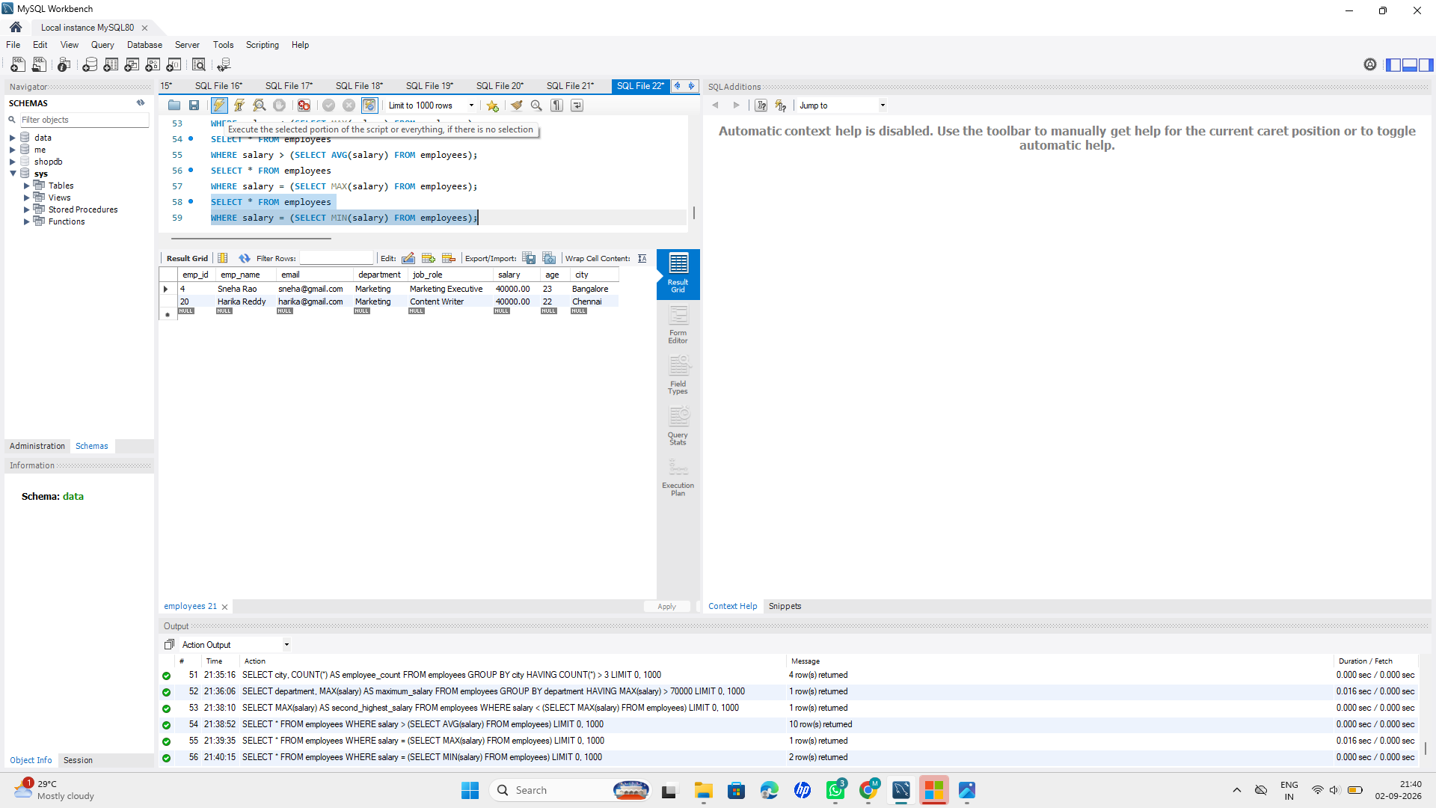
5. Find the department with the highest average salary.
Query:
SELECT department, AVG(salary) AS average_salary
FROM employees
GROUP BY department
ORDER BY average_salary DESC
LIMIT 1;
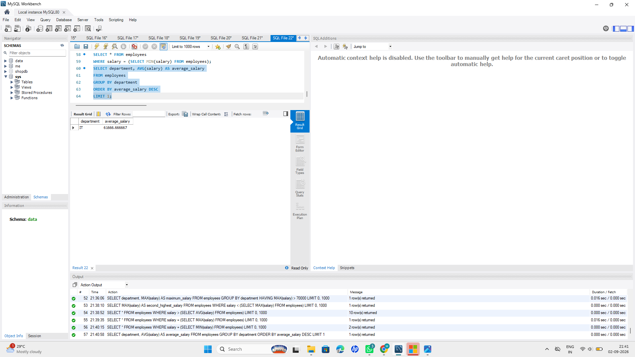
6. Find the department with the highest number of employees.
Query:
SELECT department, COUNT(*) AS employee_count
FROM employees
GROUP BY department
ORDER BY employee_count DESC
LIMIT 1;
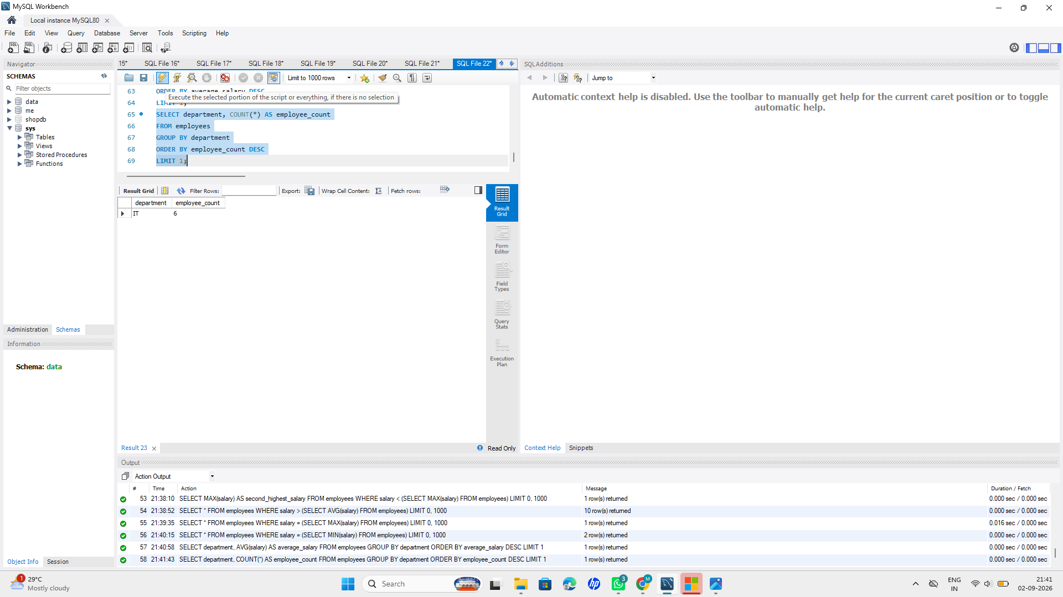
7. Find employees who earn more than the average salary of their department.
Query:
SELECT e.*
FROM employees e
WHERE e.salary > (
SELECT AVG(e2.salary)
FROM employees e2
WHERE e2.department = e.department
);
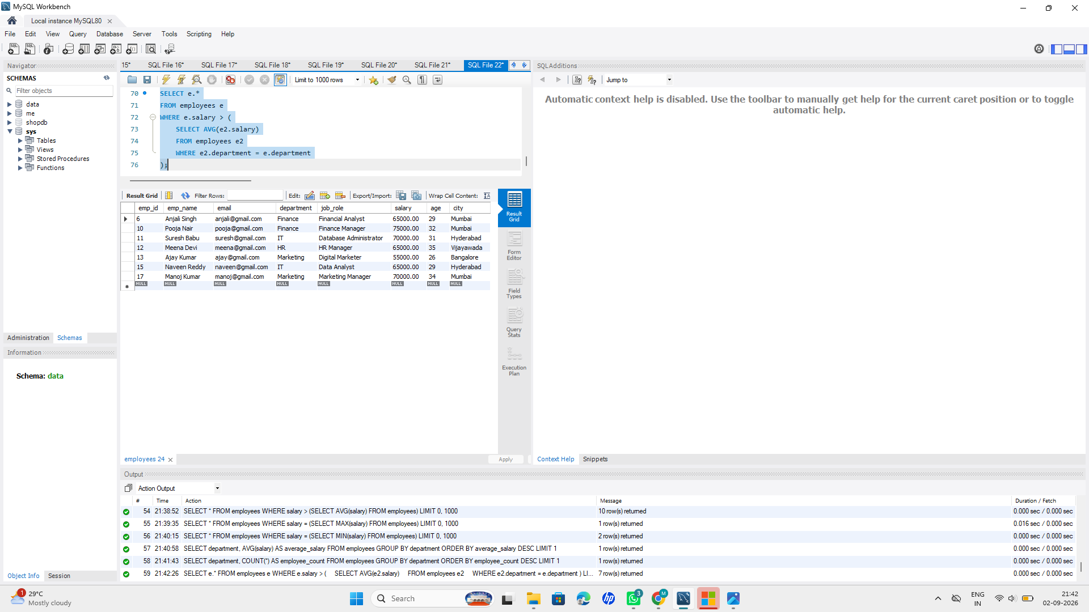
8. Find the second-highest salary in each department.
Query:
SELECT department, MAX(salary) AS second_highest_salary
FROM employees e
WHERE salary < (
SELECT MAX(e2.salary)
FROM employees e2
WHERE e2.department = e.department
)
GROUP BY department;
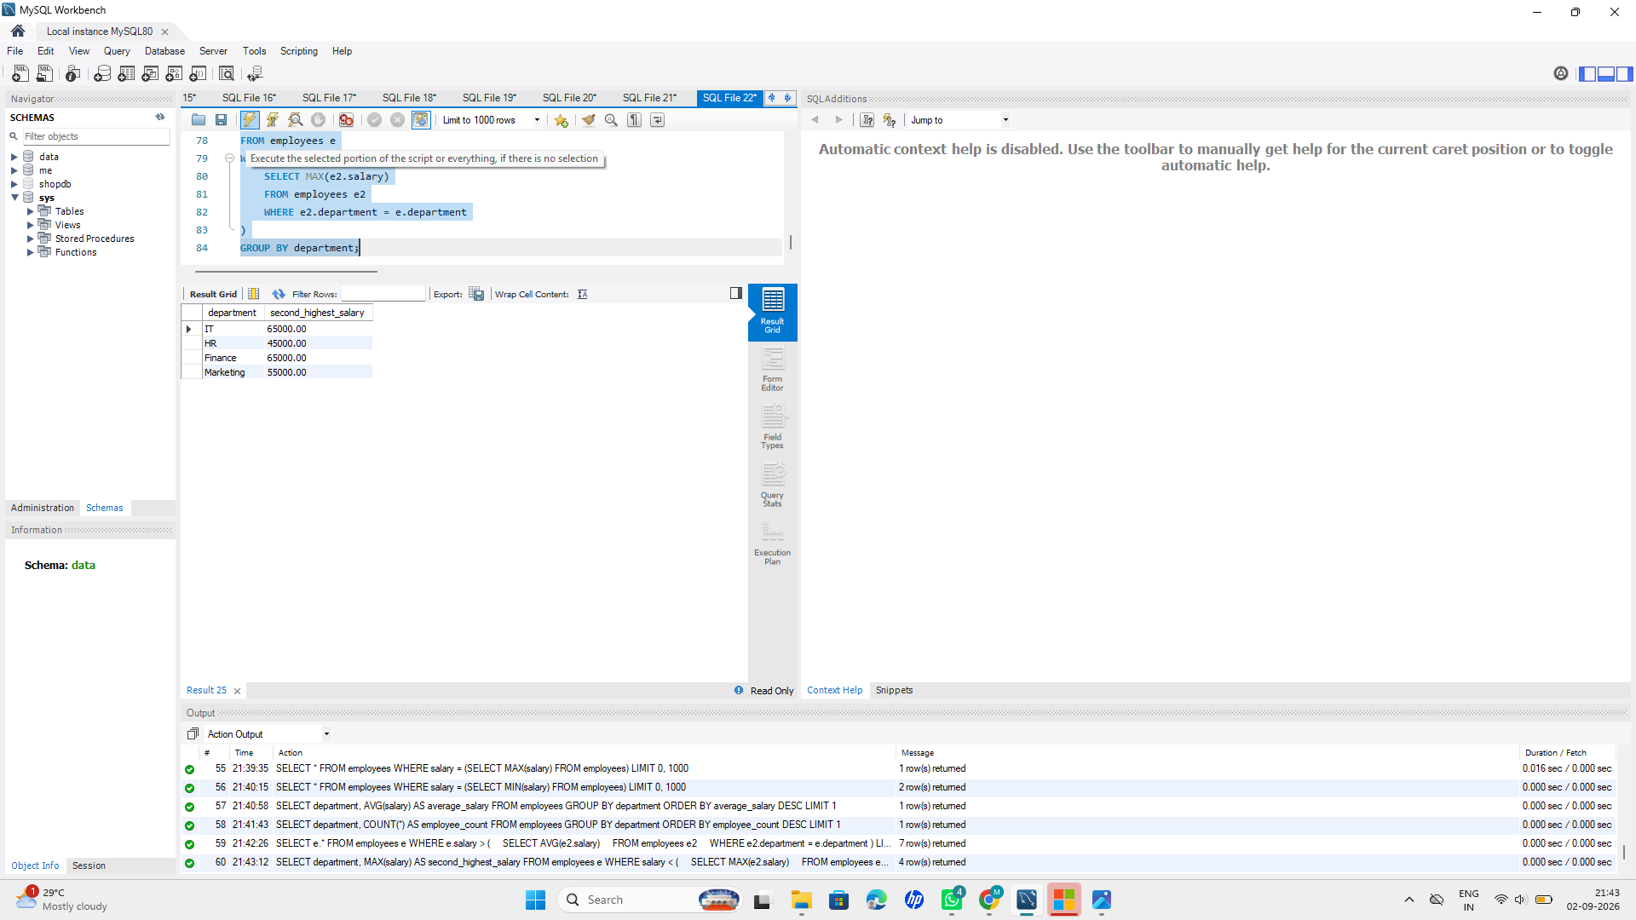
9. Find cities with the highest number of employees.
Query:
SELECT city, COUNT(*) AS employee_count
FROM employees
GROUP BY city
ORDER BY employee_count DESC
LIMIT 1;
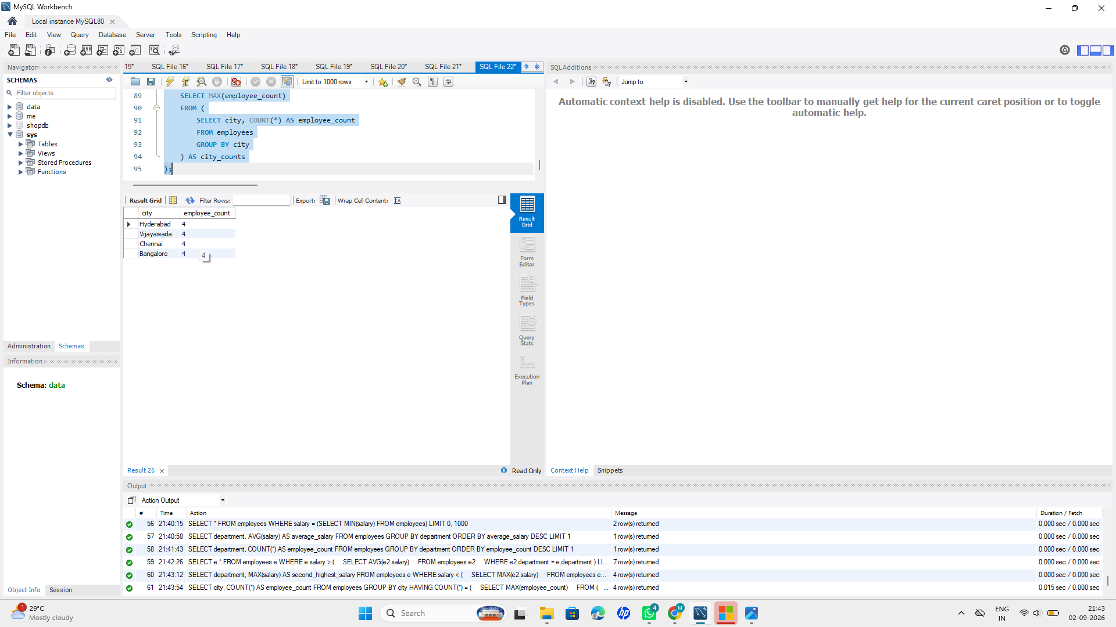
10. Find departments where the total salary is greater than a specified amount.
Query:
SELECT department, SUM(salary) AS total_salary
FROM employees
GROUP BY department
HAVING SUM(salary) > 300000;
